***“Insurance Claims-Fraud Detection”***



In this article, I’ll be going through the process of building a machine learning models to predict the that predicts if an insurance claim is fraudulent or not and It will take you through each and every steps in detail and helps you to understand the whole machine learning model building .

***INTRODUCTION***

The auto insurance industry is complicate and involves millions of dollars changing hands every day. And whenever there is a large amount of money running through complex system, there is opportunity for fraud. This fraud can be committed by professionals and company working in the industry. But it can also be committed against them.

By reading this, the first thing that comes into your mind is, what is insurance fraud. Let’s understand this.

So, what is insurance fraud?

“Improper community committed by an individual in order to obtain favorable outcomes from the insurance company”.

The insurance fraud can be broadly classified into 2 types.

1. Soft Insurance Fraud
2. Hard Insurance Fraud

***Soft Insurance Fraud***: A common example for this is, if the accident has taken place, but the amount of damage what has happened to the vehicle is very less. In such cases, the individual claims to the insurance company that huge amount of damage have occurred to the vehicle with the goal of charging the insurance company a higher bill.

***Hard Insurance Fraud***: In this type of fraud, an individual intentionally plans and invest the loss so that he can claims for the insurance from the company. A common example for this type of fraud is staging a car wreck with the goal of benefitting from the resulting claim.

This project focuses on claim data of an Automobile insurance company. Because of fraudulent claims the insurance companies are losing huge amounts of money, which indirectly affects the public. Therefore, it is important to know which claims are genuine and which are fraud.

In this article we’ll walk through how to spot insurance fraud and the consequences of engaging in it by building machine learning models and getting prediction of which claims are likely to be fraudulent. This enables an insurer to detect more fraudulent claims .

1. ***Problem Definition***

Insurance fraud is a huge problem in the industry. It’s difficult to identify fraud claims. Machine Learning is in a unique position to help the Auto Insurance industry with this problem.

In this project, we are provided with a dataset which has the details of the insurance policy along with the customer details. It also has the details of the accident on the basis of which the claims have been made.

In this example, we will be working with some auto insurance data to demonstrate how we can create a predictive model that predicts if an insurance claim is fraudulent or not.

The problem statement explains that the target variable contains the categories, so it is a **“Classification Problem”** where we need to predict whether an insurance claim is fraudulent or not.

1. ***Data Analysis***

The process of cleaning, transforming and extracting data to discover the useful information for business decision making is called data analysis.

***Importing necessary libraries and dataset***

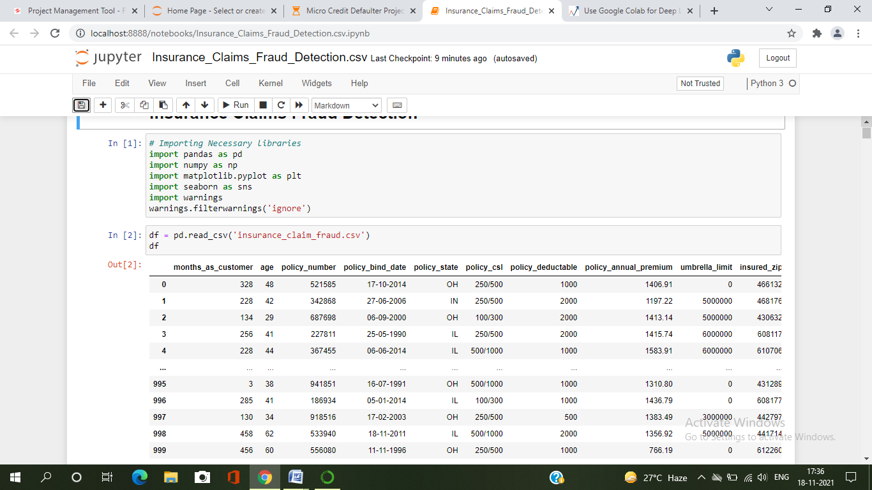

I have imported the dataset which was in the csv file using pandas. The dataset contains 1000 rows and 40 columns having both numerical and categorical data. Here I can make use of PCA to reduce the columns, but this will give huge data loss. To avoid this, I am keeping the dataset as it is.

We can also observe the null values, some “?” signs and some of the columns are in date format (dd/mm/yy), so we need to perform lots of preprocessing, cleaning to make our data usable to build the ML models.

***Data Preparation and Cleaning:***

* First, we need to check some statistical information about the dataset like checking shape, datatypes, nunique, value counts, info() etc.
* After checking the value counts, if we find any unwanted columns in the dataset then we need to do feature engineering on those columns based on the problem.
* While we ran df.info(), we found c_39 column having one unique count as NAN throughout the dataset and it is of no use, so we will drop that column.

***Checking null values***

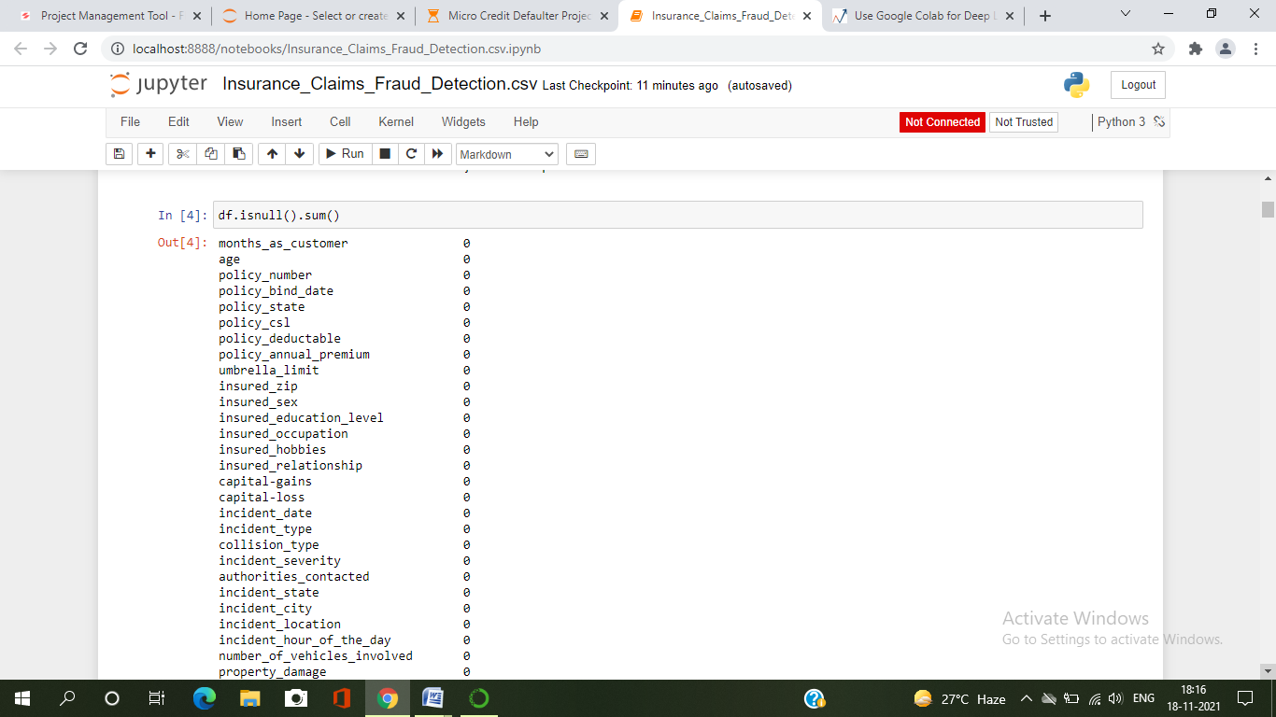

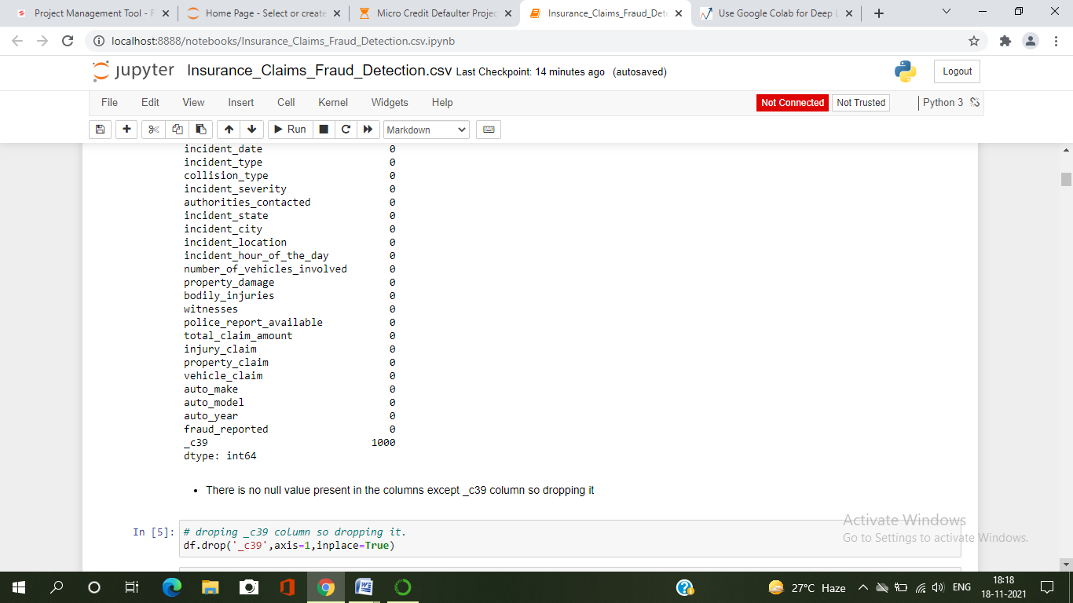

We can observe there are no missing values in the data except _c39 column so dropping it. So now we can proceed further.

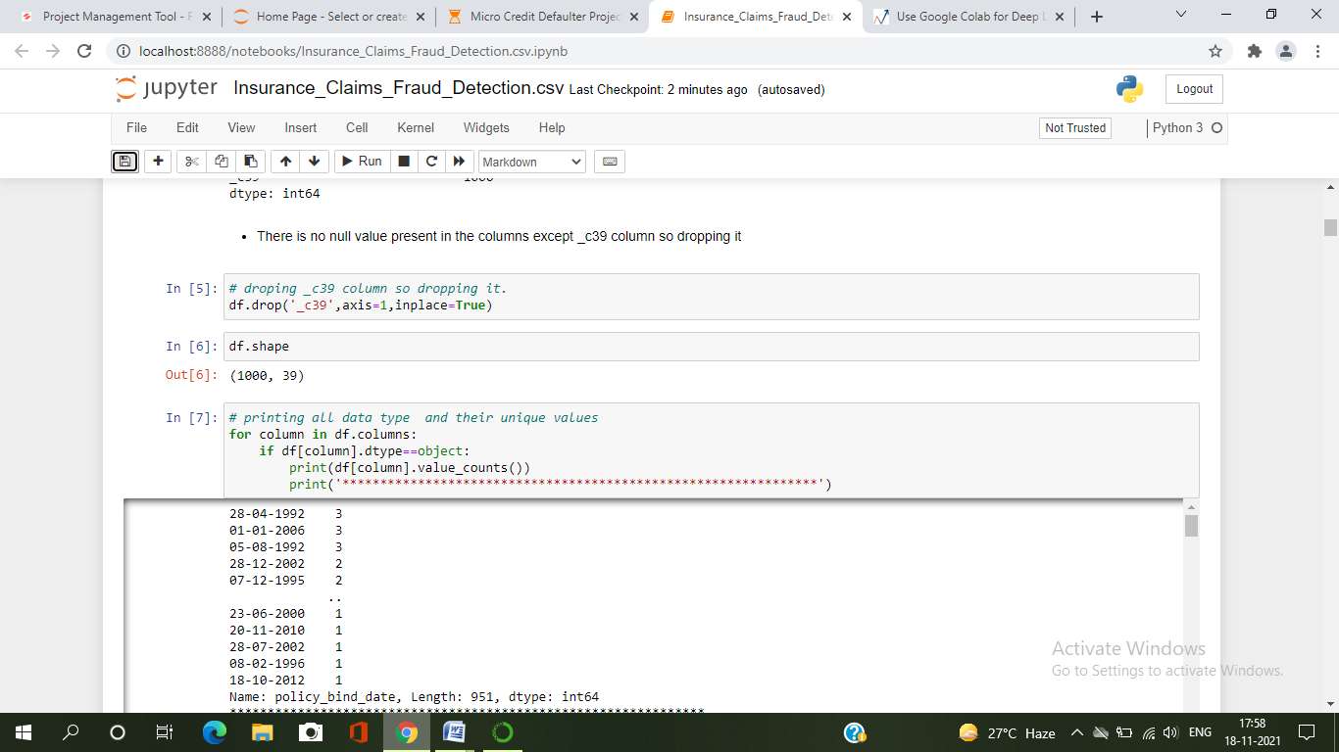

After dropping the above column, if we observe the info, the counts of all the columns are same hence there are no missing values present in the dataset.

***Feature Selection***

Replacing “?” sign

* By looking the dataset and value count function, we have found some columns having “?” sign. These are not to be considered as NAN values but we need to fill them. So here we will replace “?” sign with “No Info” .

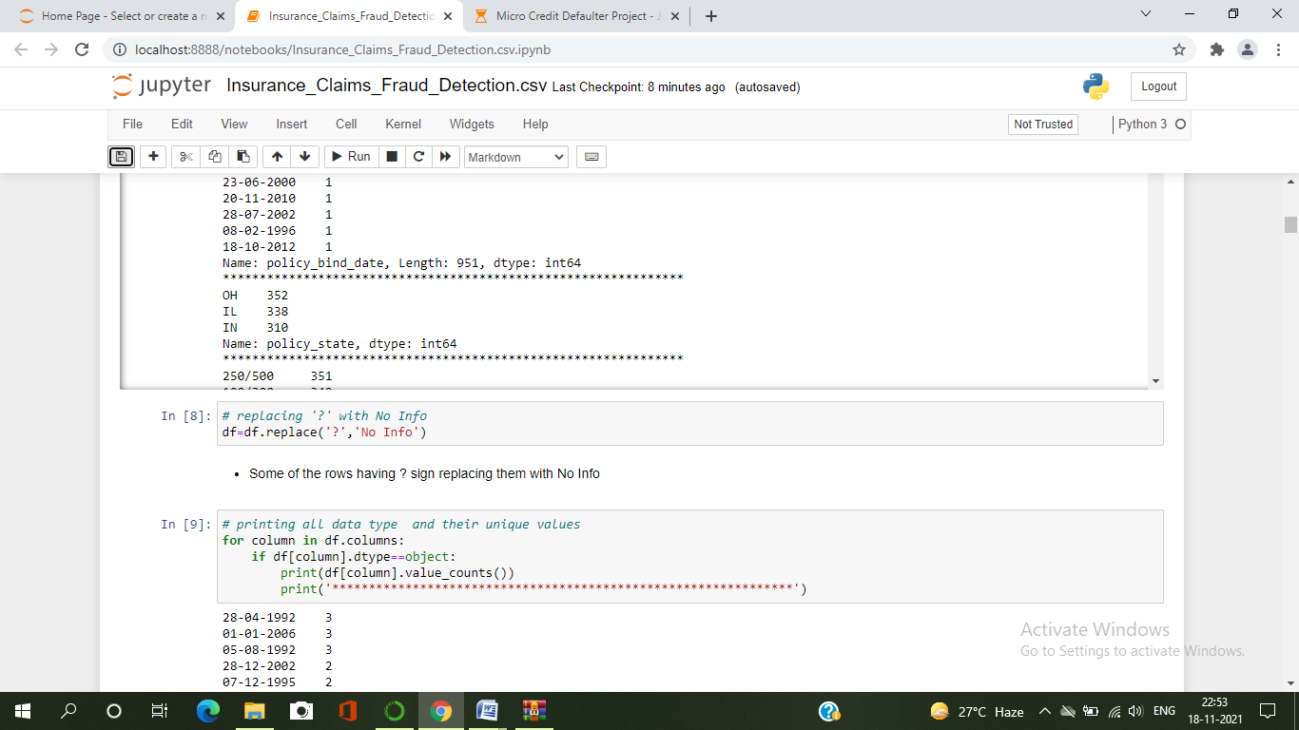

Now let’s check the list of value counts in each columns to find if there are any unexpected or corrupted entries present in the dataset.

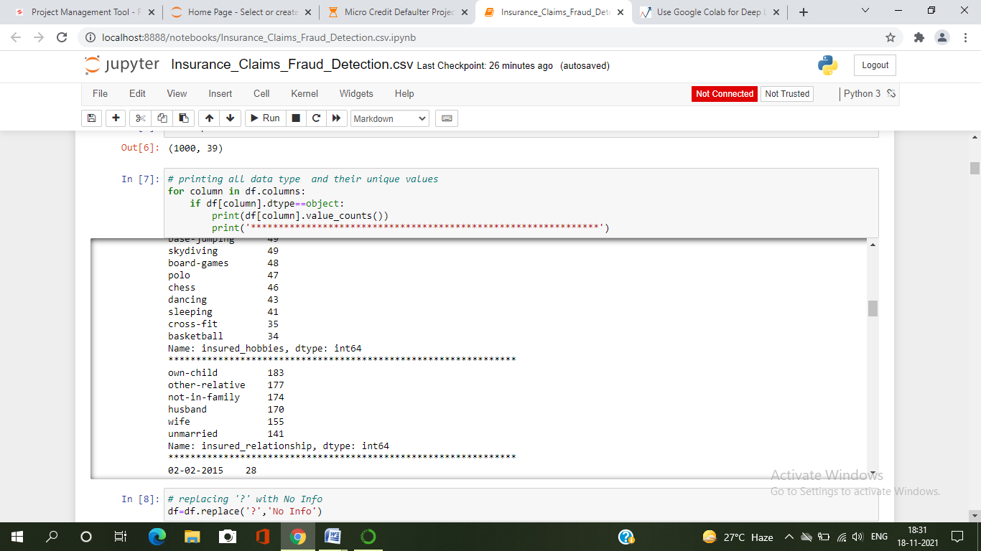

By running the above code for loop. We will get the value counts of all the columns present in the dataset.

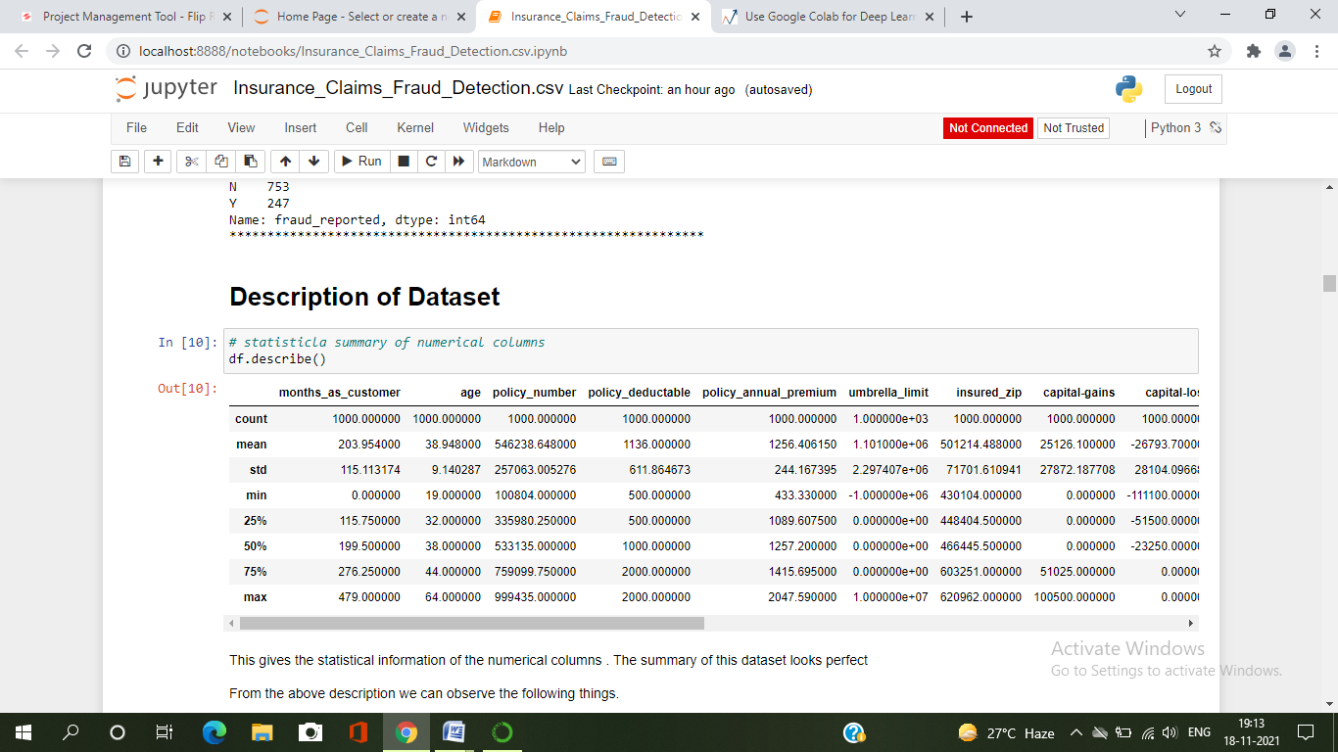

The describe method gives the statistical information of the dataset. The summary of this dataset looks perfect since there are no negative /invalid values present. It gives the summary of numerical data.

From the above description we can observe the following things

* Here the counts of all the columns are equal which means there are no missing values in the dataset.
* In some of the columns like policy_deductable, capital_gains, injury_claim etc we can observe the mean value is greater than the median(50%) which means the data in those columns are skewed to right.
* And in some of the columns like total_claim_amount, vehicle_claim etc we can observe the median is greater than the mean which means the data in the columns are skewed to left.
* And some of the columns have equal mean and median that means the data symmetric and is normally distributed and no skewness present.
* There is a huge difference in 75% and max it shows that huge outliers present in the columns.
* Here we can notice the counts, mean, standard deviation, min, 25% percentile, median(50%), 75% percentile and max values from this describe method.

By looking into the value counts of each column we came to know that the column umbrella limit contains about 80% of zero values. It might create skewness in the data so better to drop this column here only.

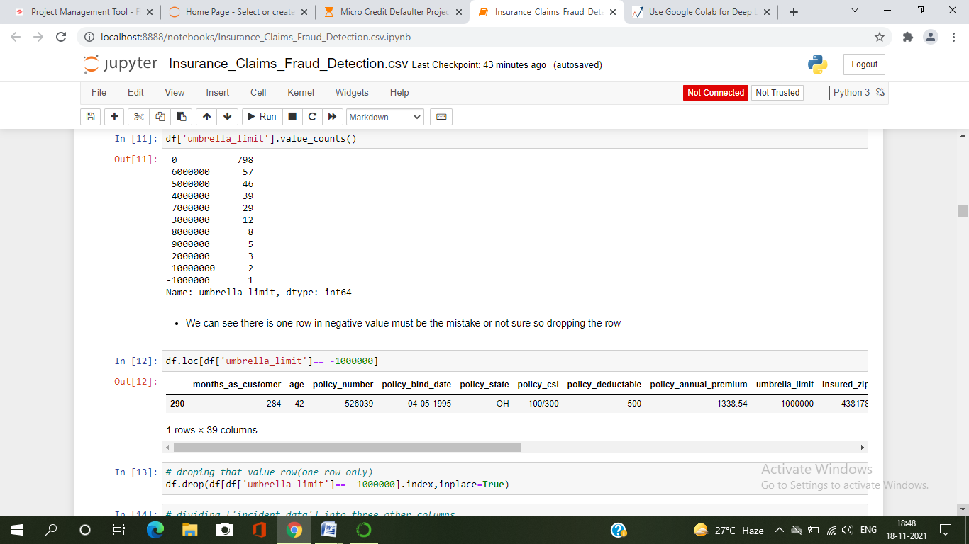

***Feature Extraction***

* The columns policy_bind_date and incident_date have data in the form of dd/mm/yy and showing object data type which should be in datetime data type that means the python is not able to understand the type of these columns and giving default data type, this could be because of some special characters present in the data.
* So, we will convert this object data type into datetime data type to use them properly for the prediction and we will extract the values from these columns.

***Incident_date*** :

It gives us that, on which date the incident occurs. This column contains only 2015 year data so I have extracted only day and month from this column and after that dropped the column accordingly.

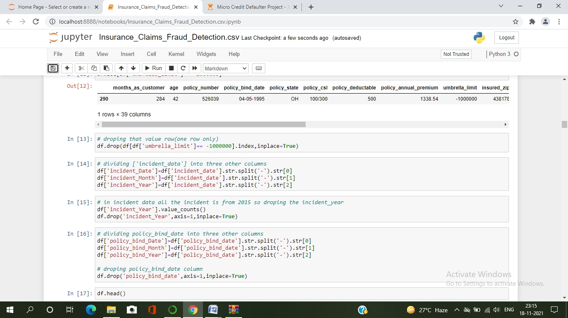

***Policy_bind_date :***

Policy bind date means, on which date the policy was made. On this basis I have extracted day, month and year of policy made and dropped policy_bind_date as it is of no use.

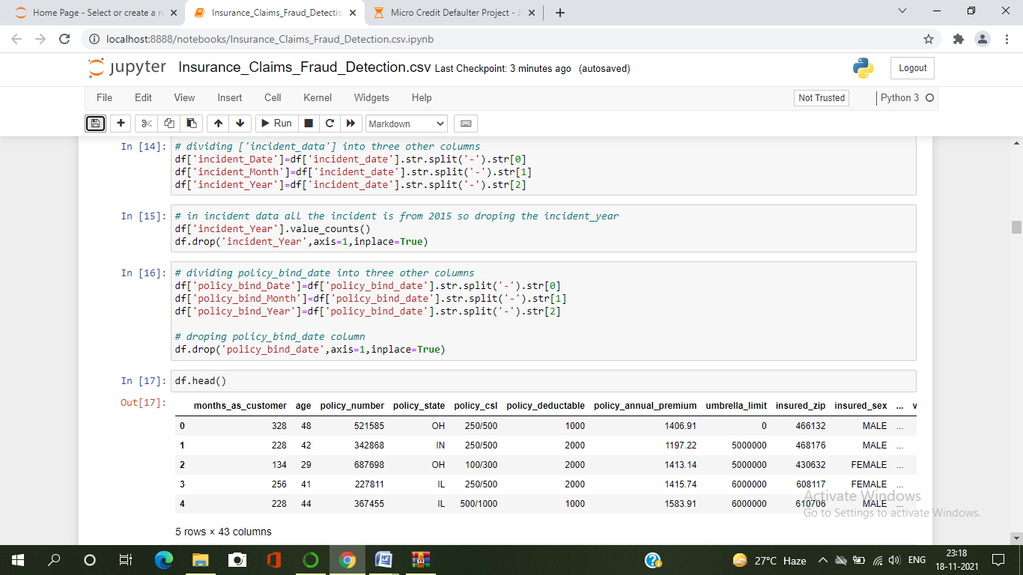

* There is a column named insured_zip, it is the zip code given to each person. If we take a look at the value count and unique values of the column insured_zip, it contains 995 unique values that means the 5 entries are repeating.
* Since it is giving identier information about the person , it is not important for the processing so we can drop this column as well.
* Also, the columns policy_number and incident_location have only one unique count through out the data, it is not required for the prediction so dropping them.

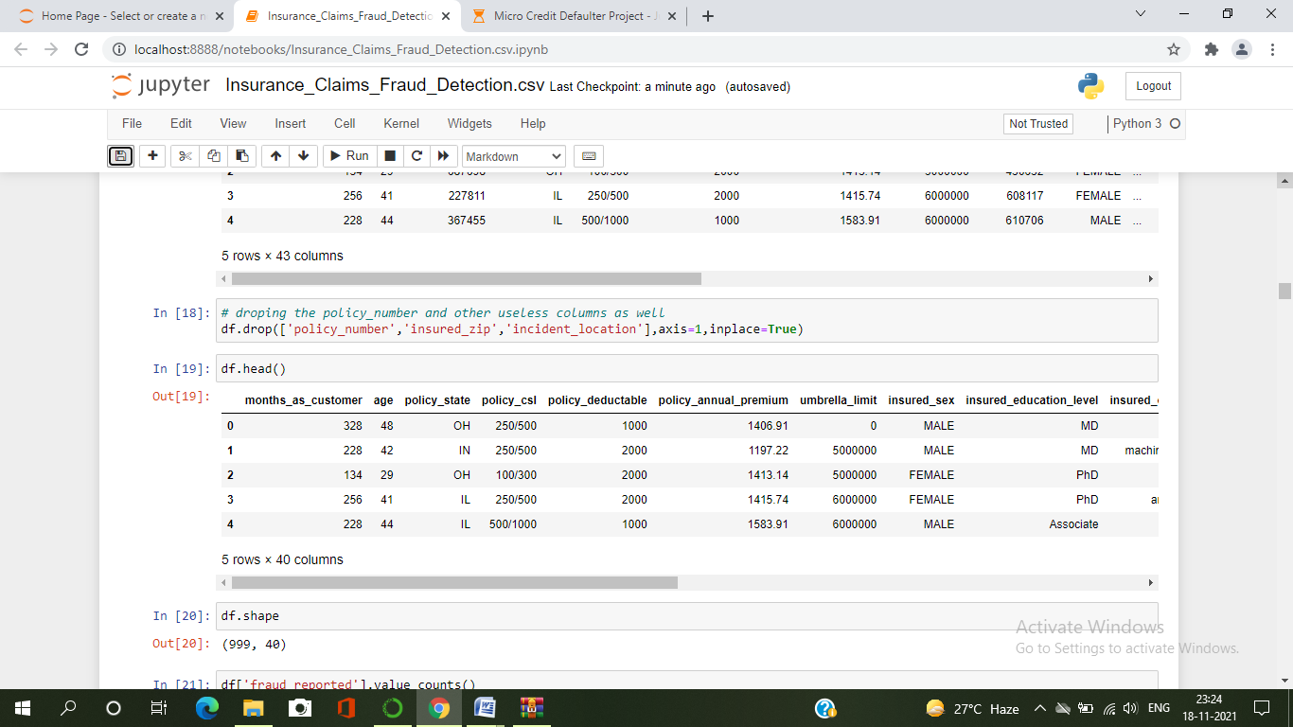

So here we have successfully dealt with the feature engineering and now we will move further to know if data is balanced or not .

***Data Visualization***

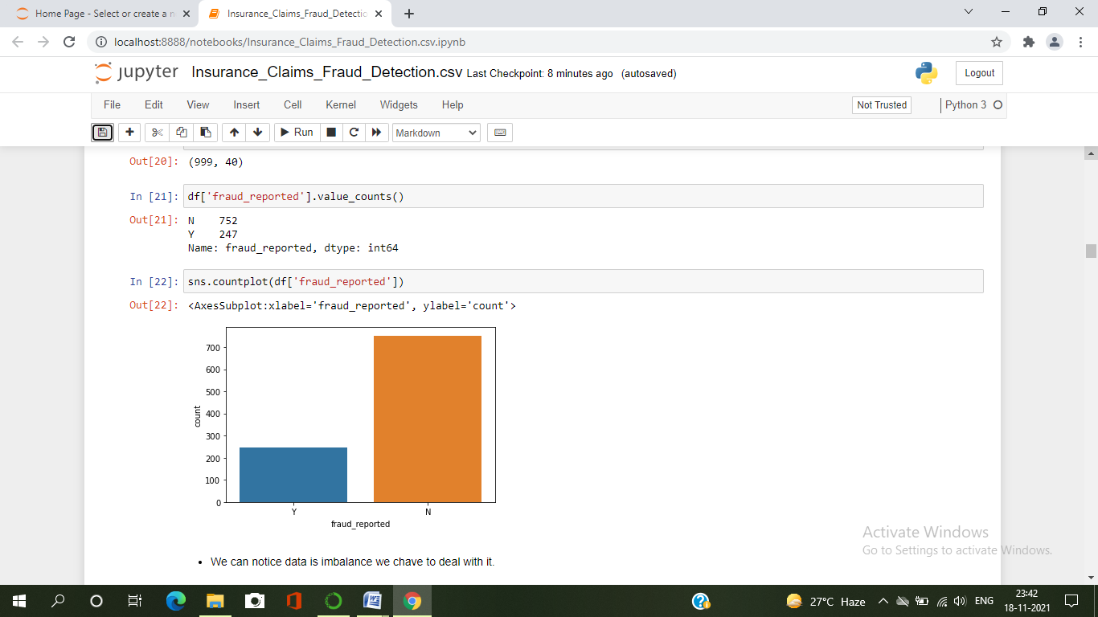

From the plot we can observe that the count of “N” is high compared to “Y”. Here we can assume that “Y” stands for “Yes” that is the insurance claim is fraudulent and “N” stands for “No” means the insurance claim is not fraudulent. There are around 247 frauds and 753 non-frauds.

Since we are dealing the classification problem, the target fraud_reportedit indicates the class imbalance issue. We need to balance the data before proceed with our models.

***Correlation between the label and features using Heat map***

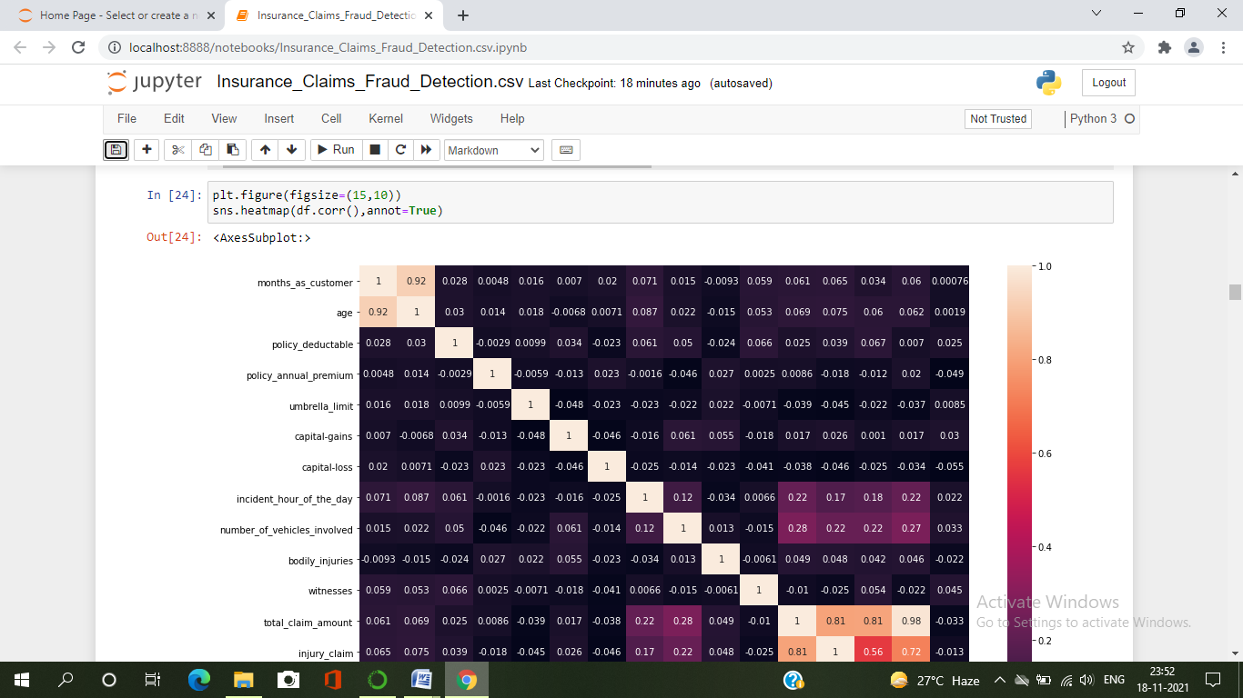

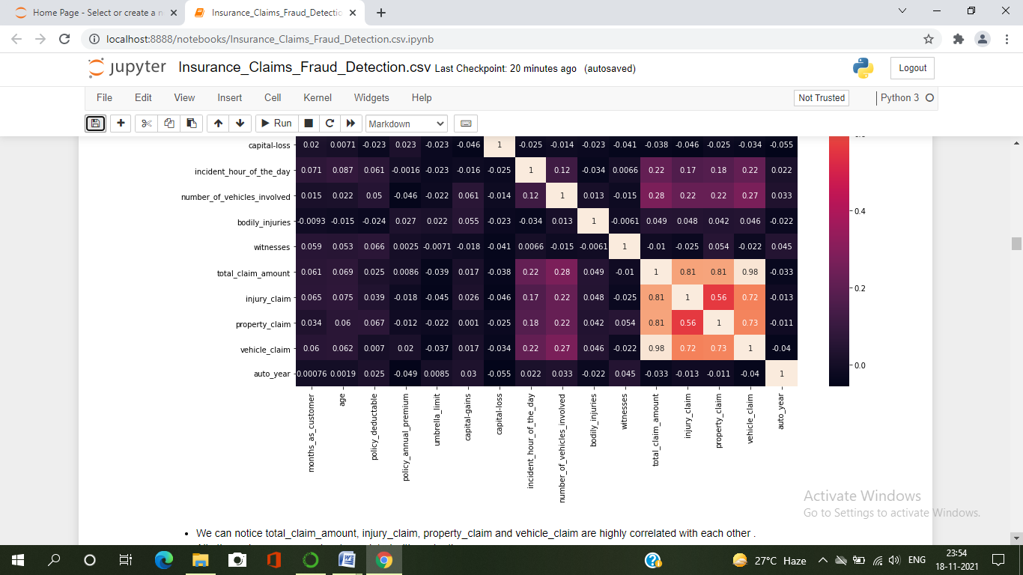

This heatmap shows the correlation matrix by visualizing the data. We can observe the relation between one feature to other.

This heat map contains both positive and negative correlation.

* There is very less correlation between the target and the label.
* We can observe the most of the columns are highly correlated with each other which leads to the multicollinearity problem.
* We will check the VIF values to overcome with this multicollinearity problem.

Now we will compare the features and label by visualizing the data.

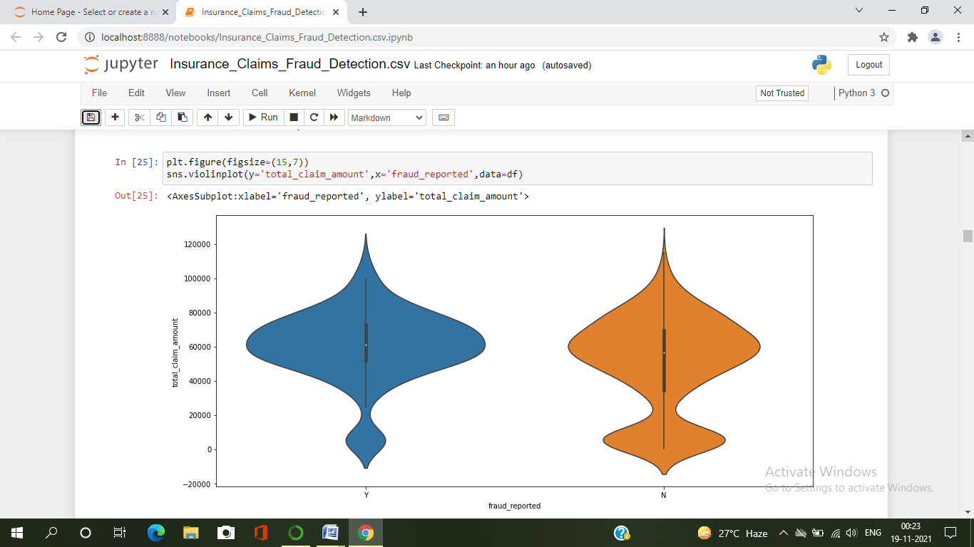

* Here I have used violinplot to compare total_claim_amount and fraud_reported . we can noticet that the most of the fraud reported found where total claimed amount 50000 to 70000.

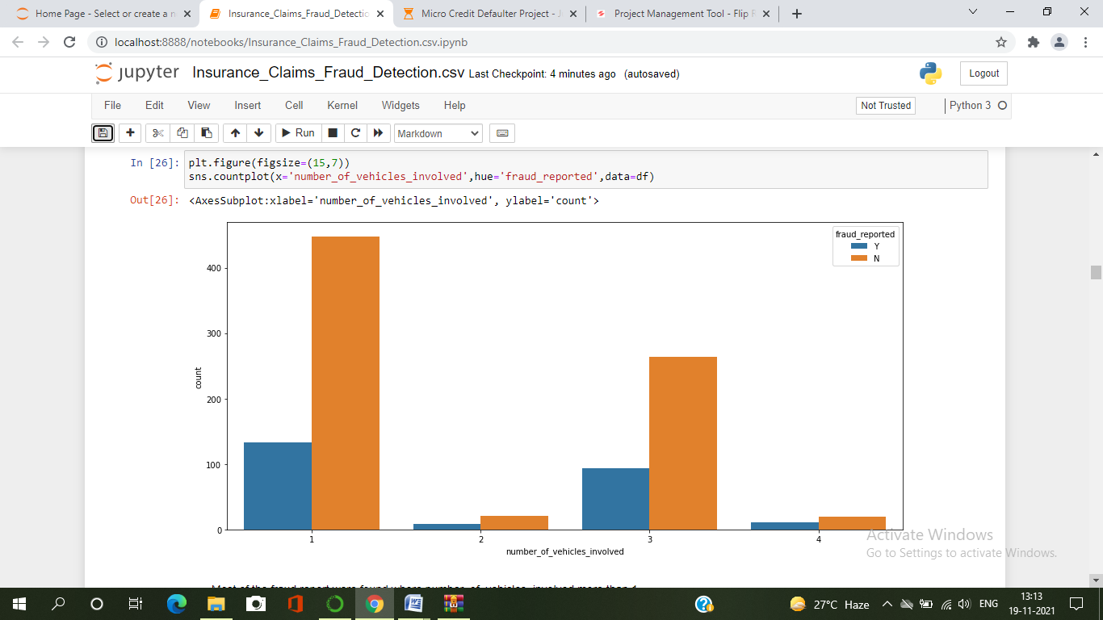

* Here I have used countplot to compare number_of_vehicles_involved and fraud_reported . we can notice that the most of the fraud reported found where number_of_vehicles_involved more than 1.

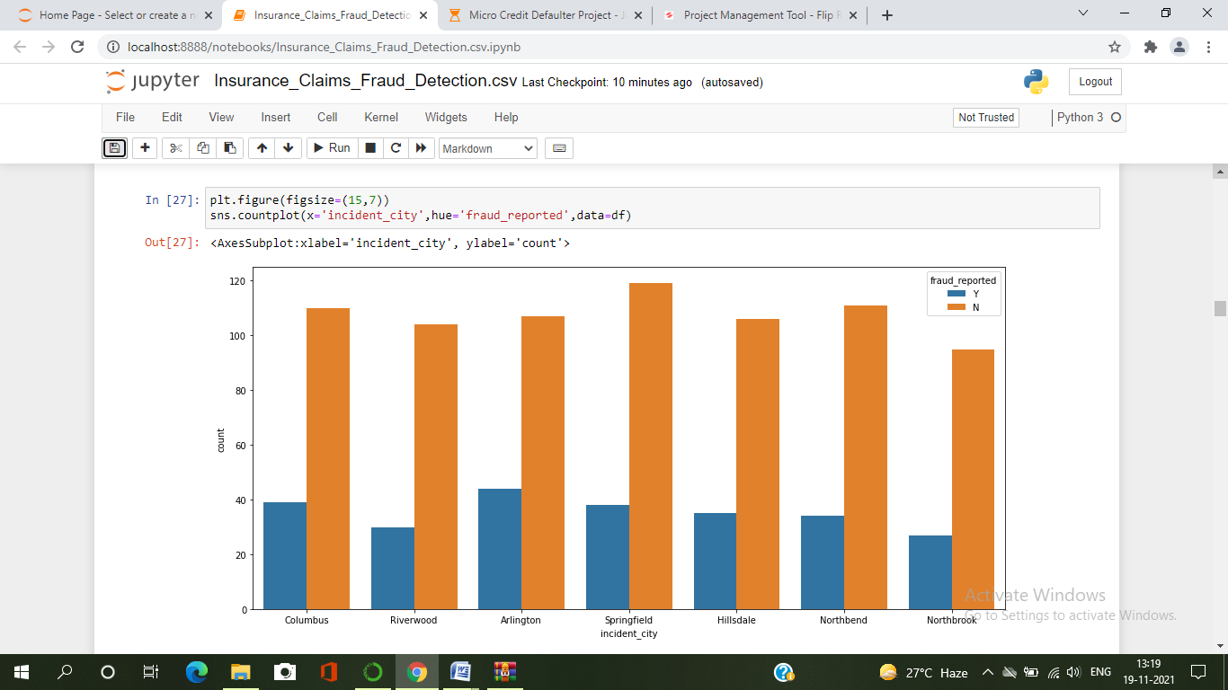

* Here I have used countplot to compare incident_city and fraud_reported . we can notice that in all cities fraud reported counts are almost same.

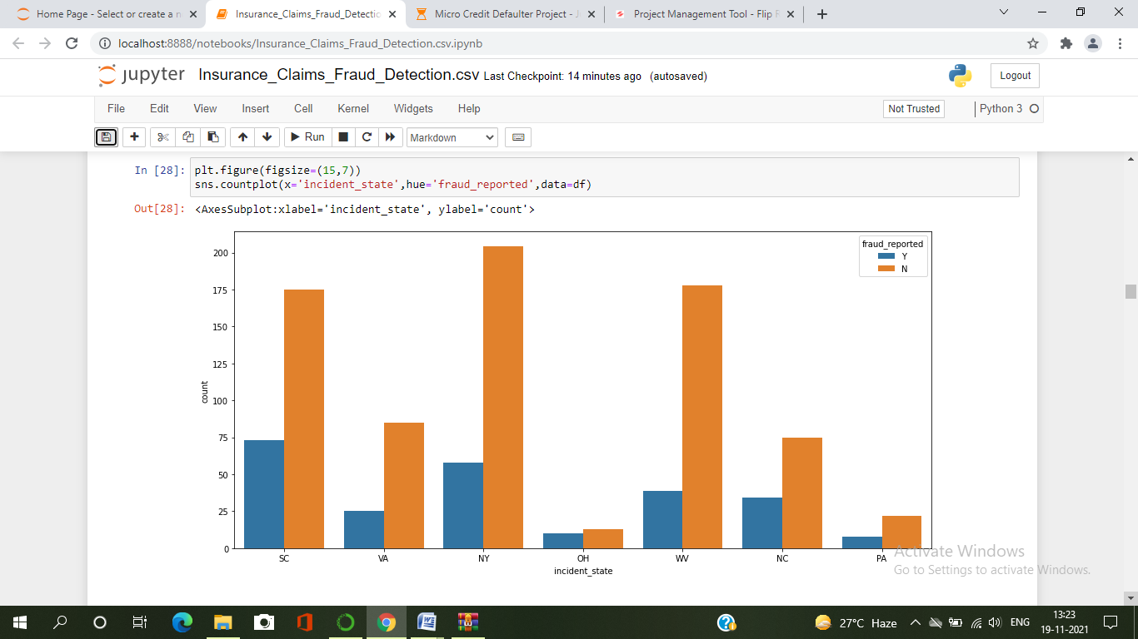

* Here I have used countplot to compare incident_state and fraud_reported . we can notice that most of the fraud reported found where incident state was SC, NY, OH, NC and PA.

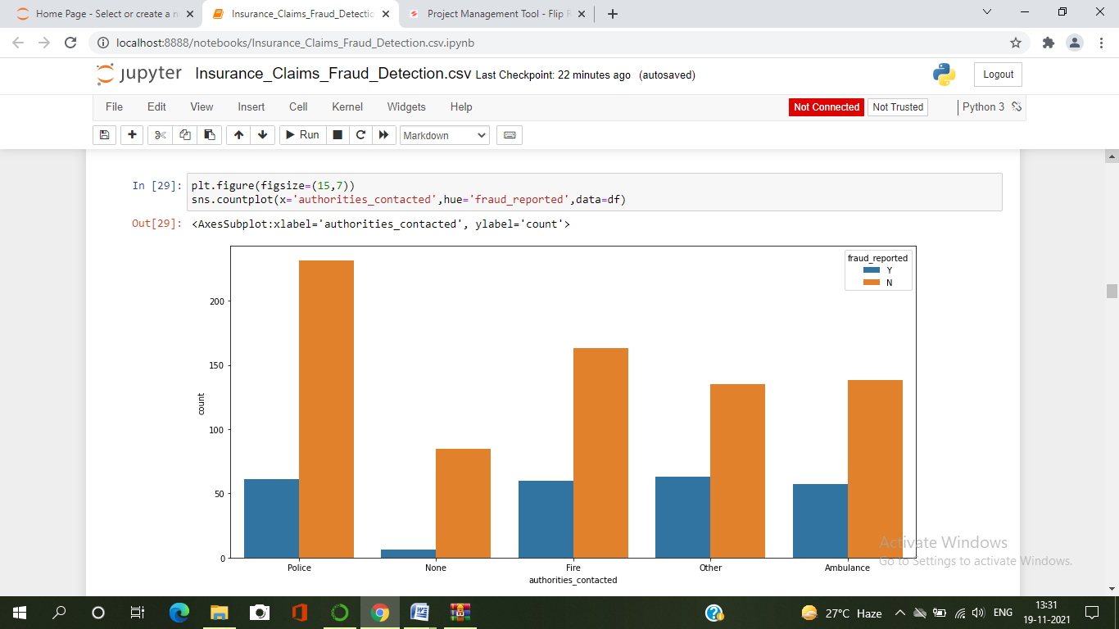

* Here I have used countplot to compare authorities_contacted and fraud_reported . we can notice that most of the fraud reported found where cx have contacted authorities_contacted of Fire, Other and Ambulance.

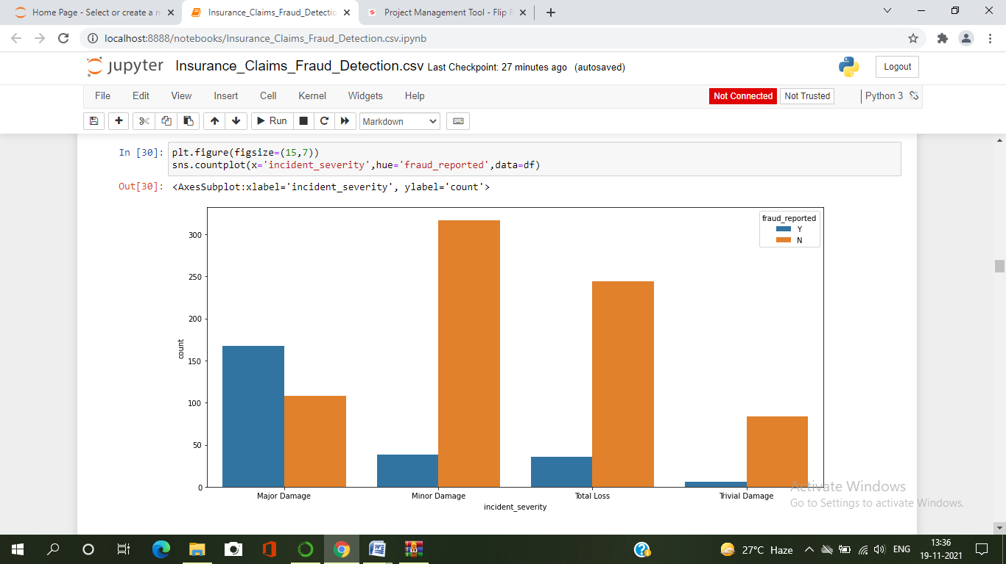

* Here I have used countplot to compare incident_severity and fraud_reported . we can notice that most of the fraud reported claim are Major Damage, most of them are counted as fraud and also there are very less fraud report in Trivial damage.

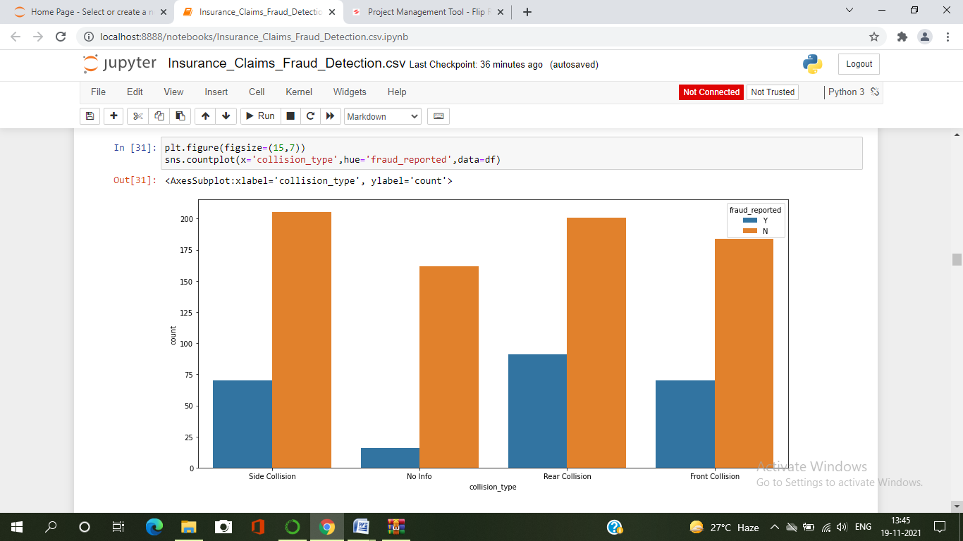

* Here I have used countplot to compare collision_type and fraud_reported . we can notice that most of the fraud reported claims in Side Collision, Rear Collision and Front Collision . Some of reported claim we have those are in no info of collision type.

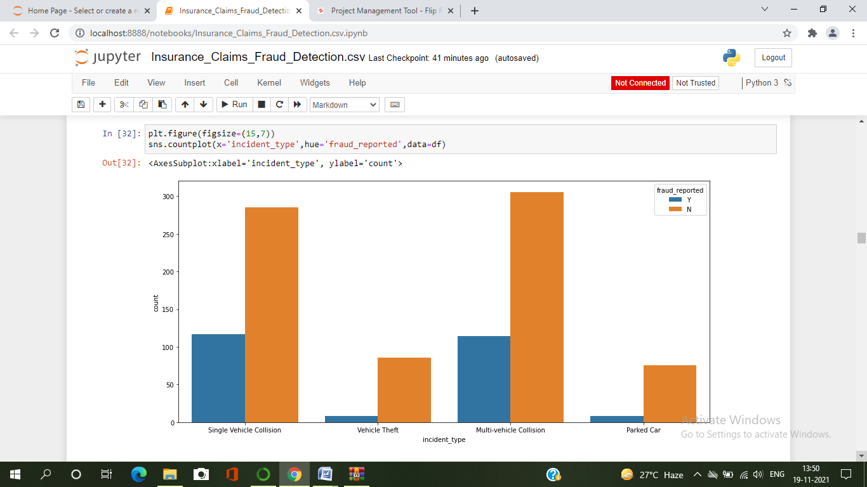

* Here I have used countplot to compare incident_type and fraud_reported . We have most claim reported and fraud reported in Single vehicle collision and multi-vehicle collision incident type. In other two incident type vehicle theft and parked car are very less fraud report.

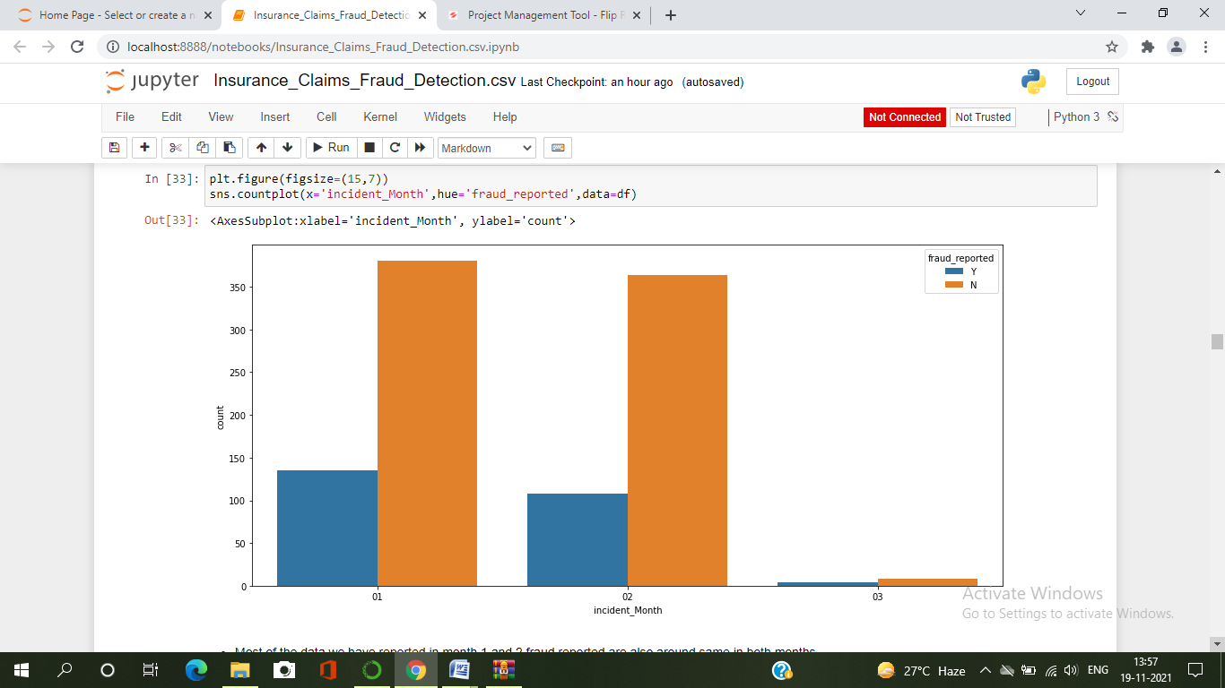

* Here I have used countplot to compare incident_Month and fraud_reported . Most of the data we have reported in month 1 and 2 fraud reported are also around same in both months .

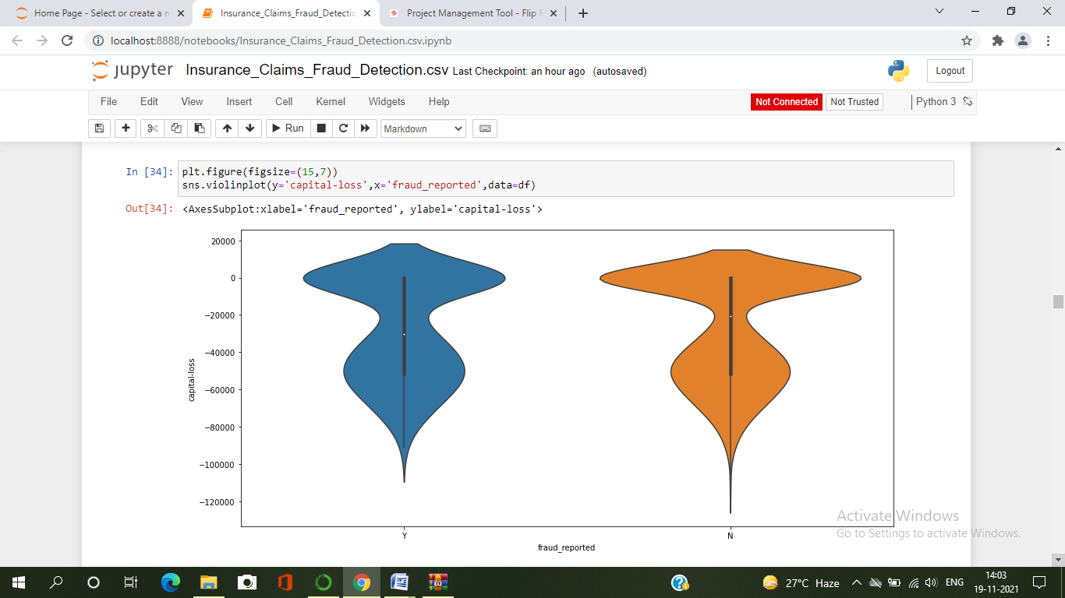

* Here I have used violintplot to compare capital_loss and fraud_reported . Most of the fraud reported we see in cx those capital loss are -40000 to -60000.

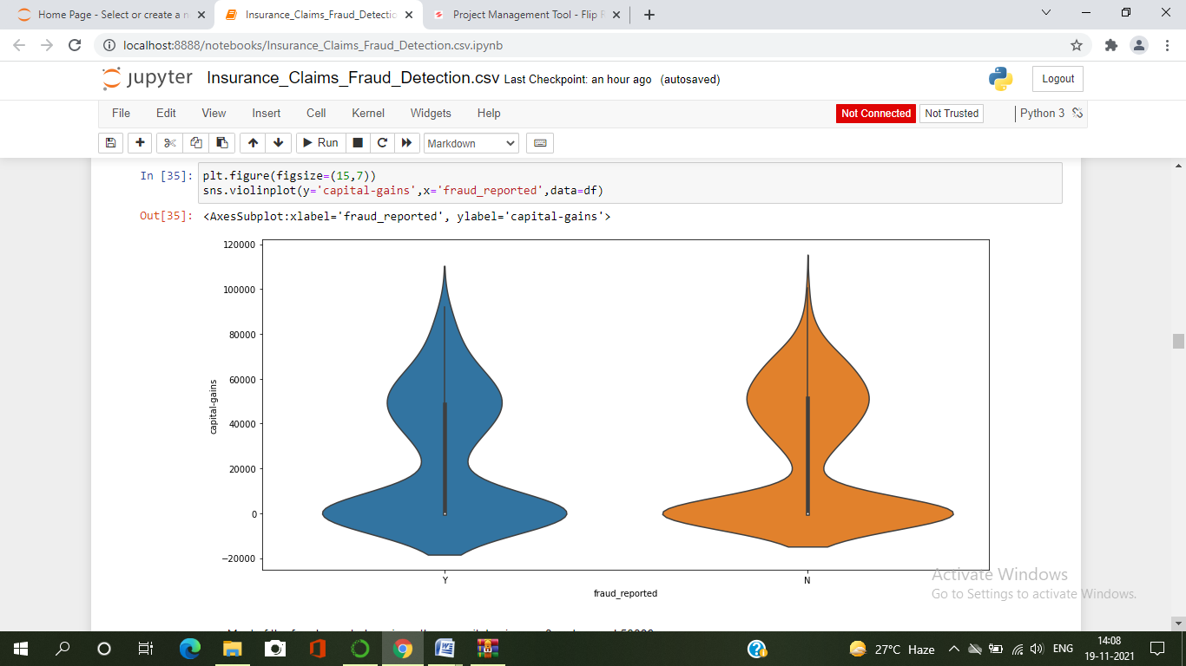

* Here I have used violintplot to compare capital_gains and fraud_reported . Most of the fraud reported we see in cx those capital loss are 0 to 50000.

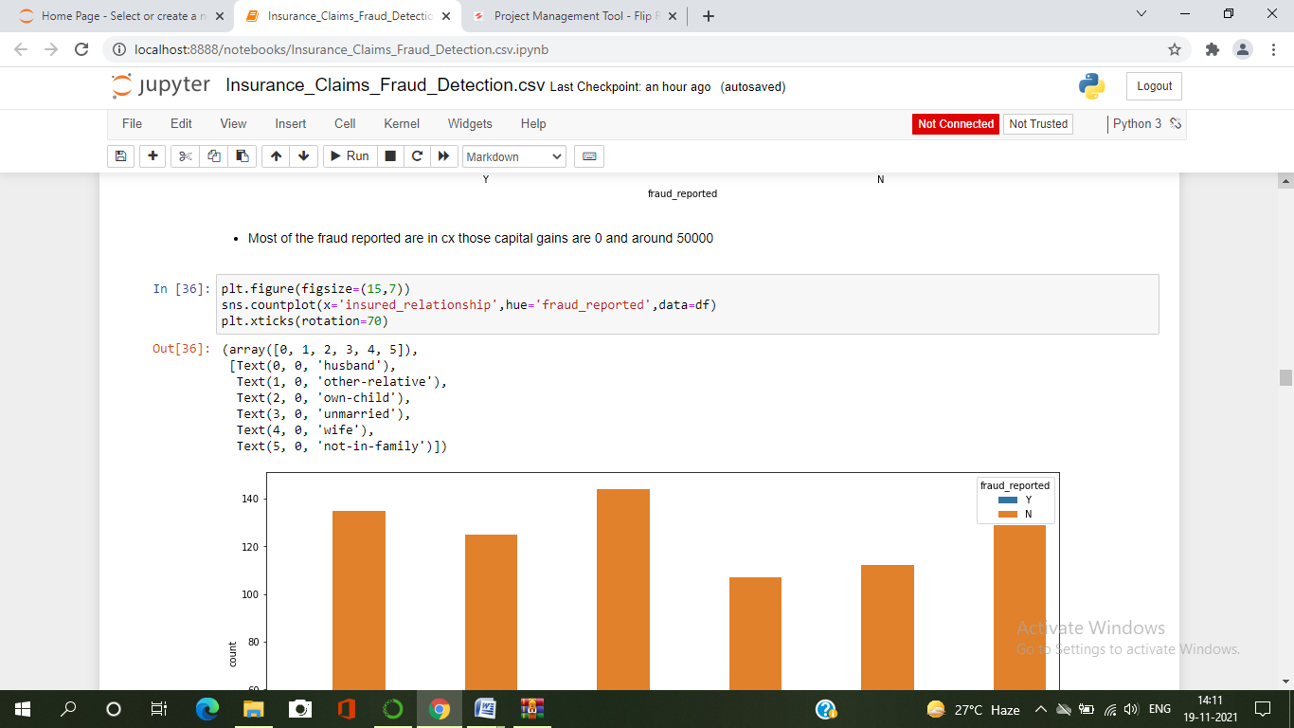

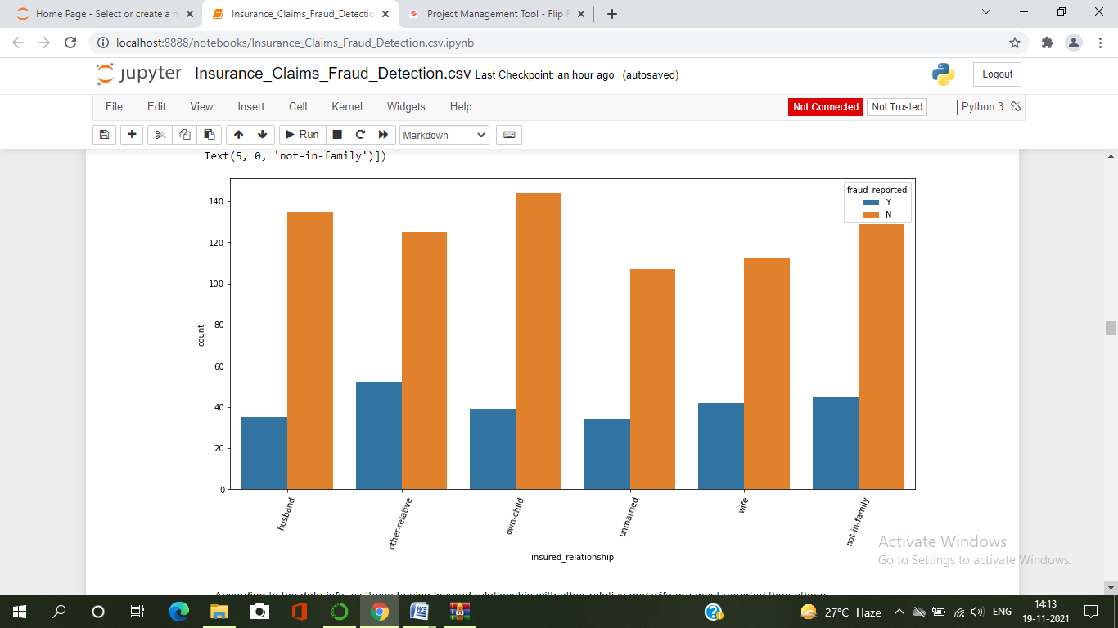

* Here I have used countplot to compare insured_relationship and fraud_reported . According to the data info, cx those having insured_relationship with other relative and wife are most reported and other.

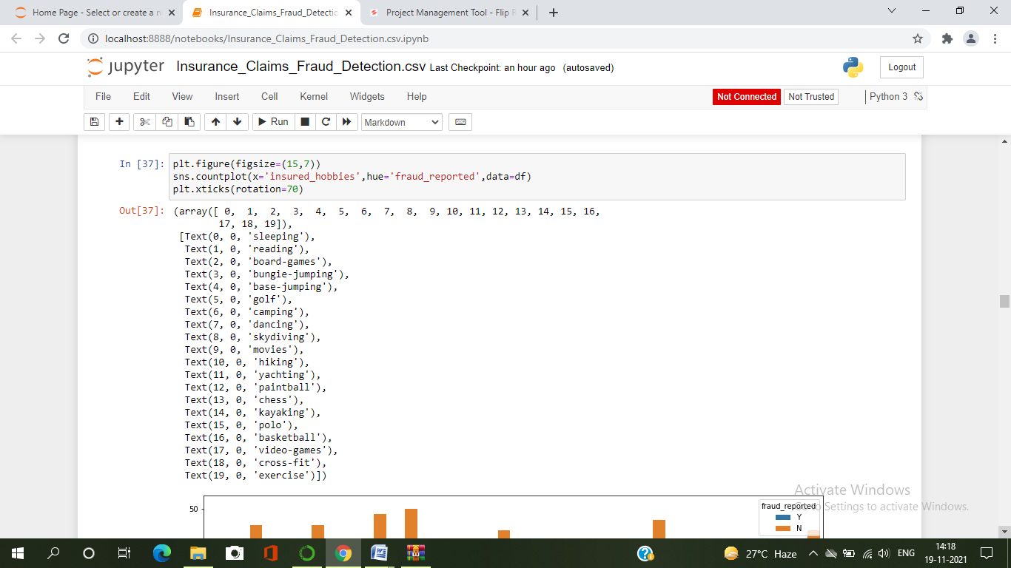

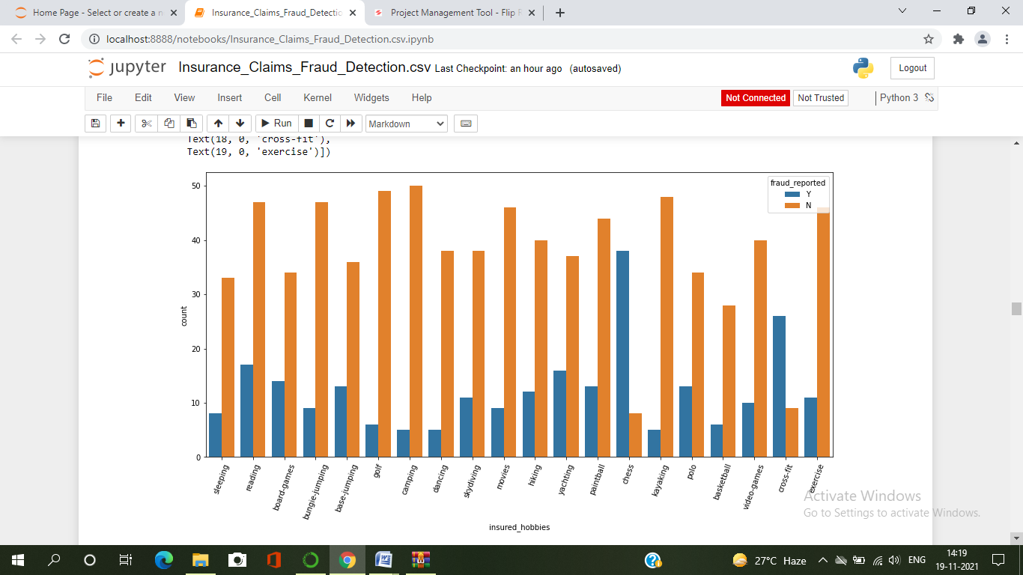

* Here I have used countplot to compare insured_hobbies and fraud_reported . According to the data info, cx those hobbies are Chess, are most fraud reported cx.
* We also can see the cx those hobbies are cross-fit, are also most fraud reported cx.
* After that cx those hobbies are reading , board games, base-jumping, yechting , painball, polo and etc. also most fraud report cx than others.

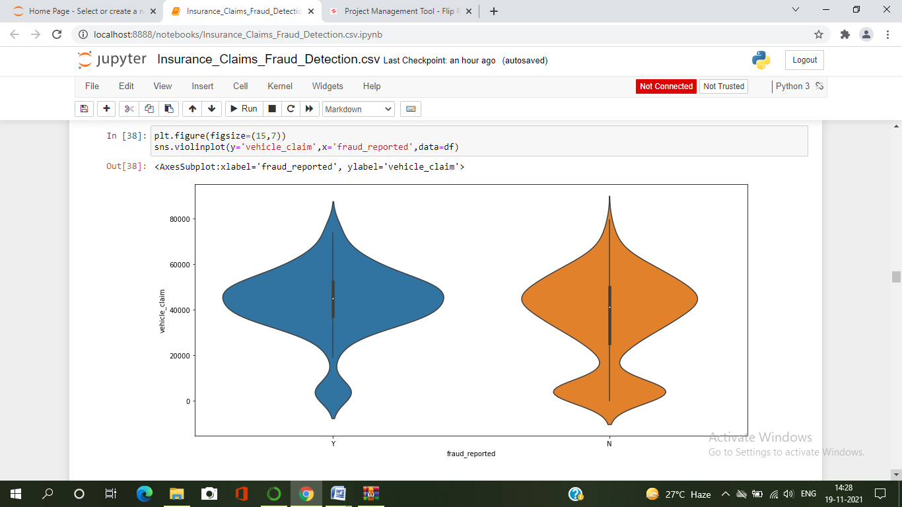

* Here I have used violinplot to compare vehicle_claim and fraud_reported .
* In vehicle_claim most of the cx are between 100 to 6500.
* Fraud report is higher in cx are between 3500 to 5500 vehicle_claim.

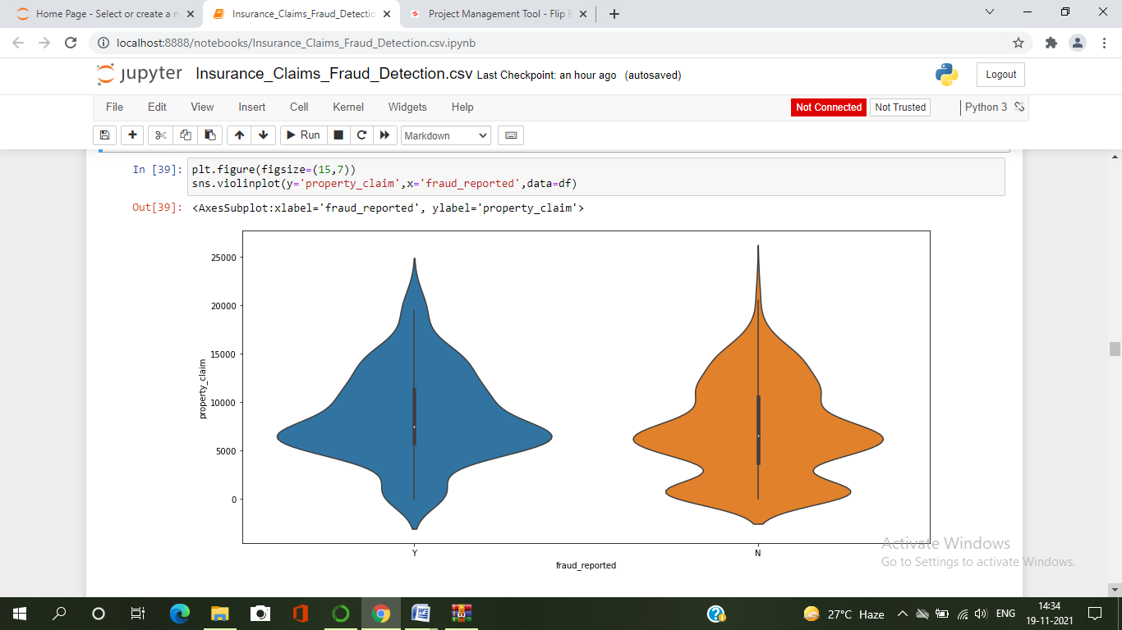

* Here I have used violinplot to compare property_claim and fraud_reported . So here we can notice in property_claim fraud reported is higher in cx claimed of 5000 to 8000.

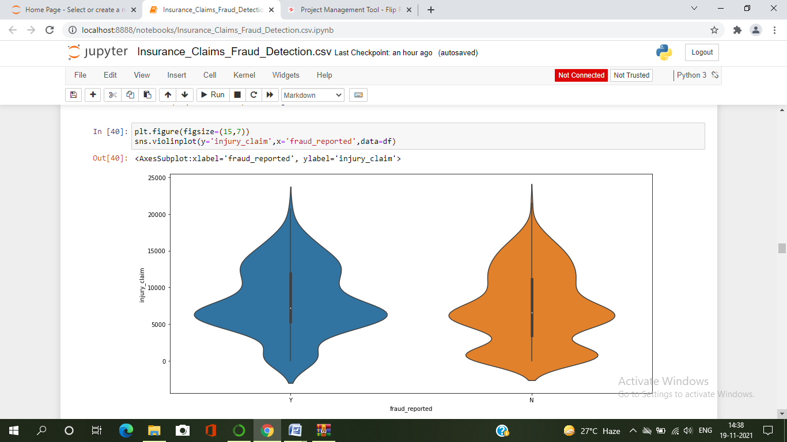

* Here I have used violinplot to compare injury_claim and fraud_reported .
* And from the above violinplot we can observe most of the cx injury claim is 100 to 15000.
* Most fraud reported cx are between 5000 to 8000 injury claim.

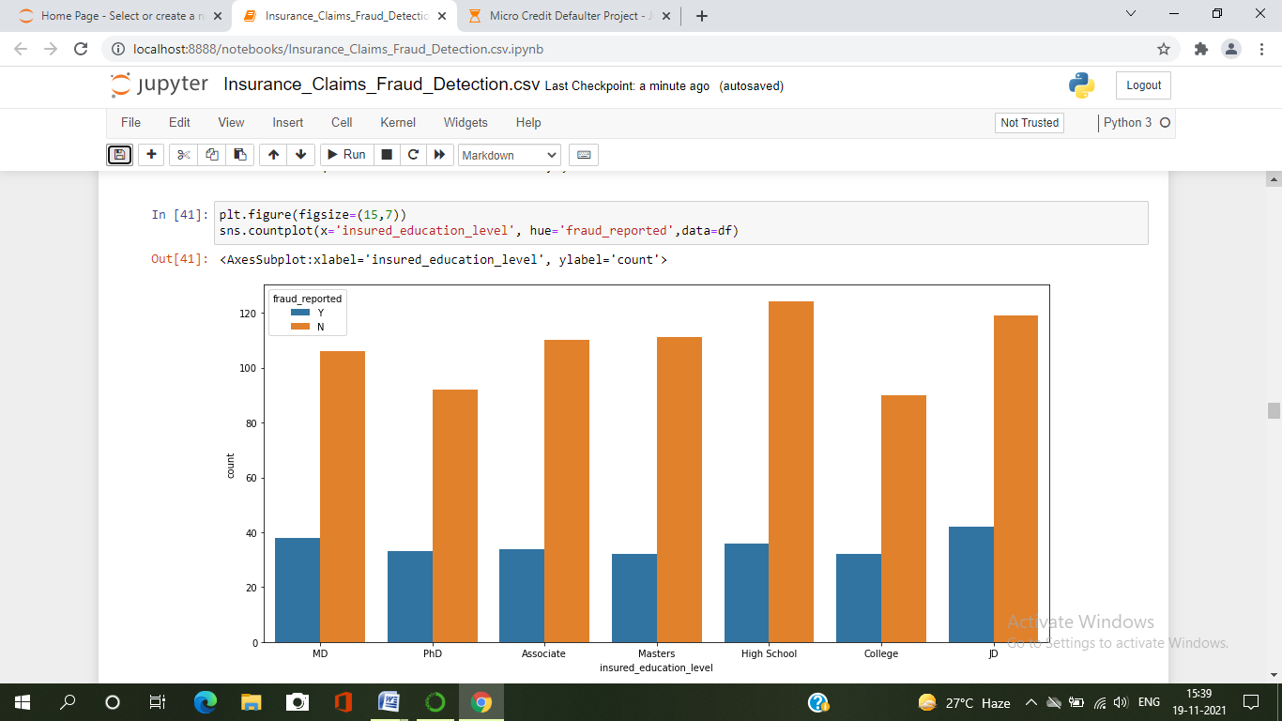

* Here I have used countplot to compare insured_education_level and fraud_reported .
* We can observe here that the higher cx those are education level is High School and least cx in PhD and College.
* There is very little difference in fraud report in all kind of cx.
* Fraud report is little higher in cx those education level is JD, MD, PhD, and College than others.

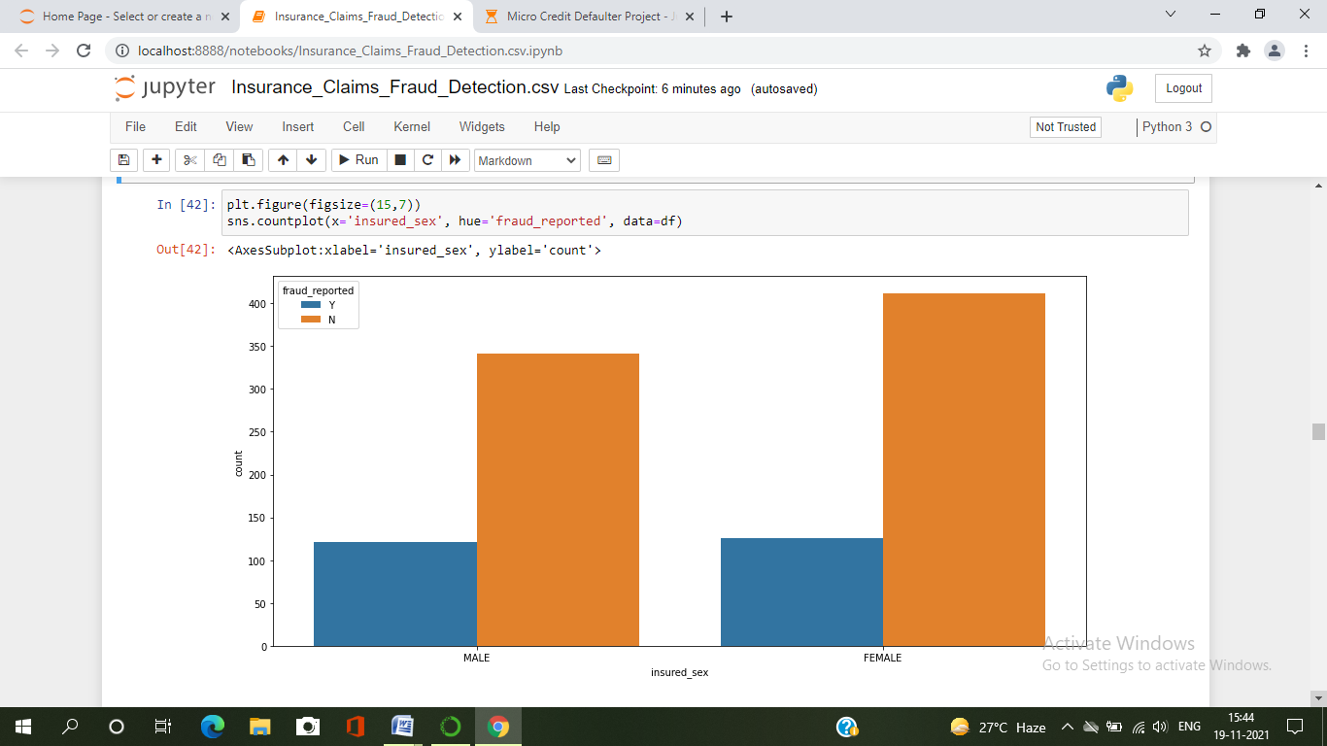

* Here I have used countplot to compare insured_sex and fraud_reported .
* We have more cx in Female than the Male.
* But fraud reported is little high in Male cx.

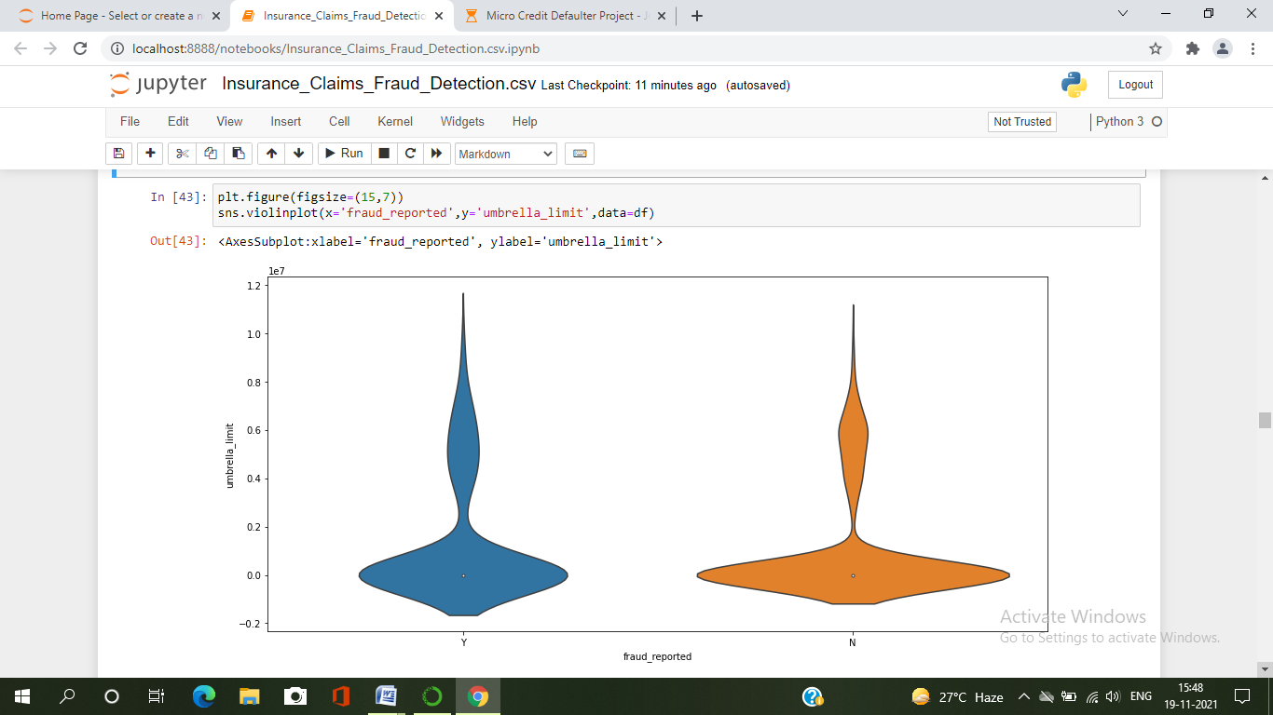

* Here I have used violinplot to compare fraud_reported and umbrella_unit.
* Most of cx we have their umbrella limit is 0.
* fraud reported is also high there .

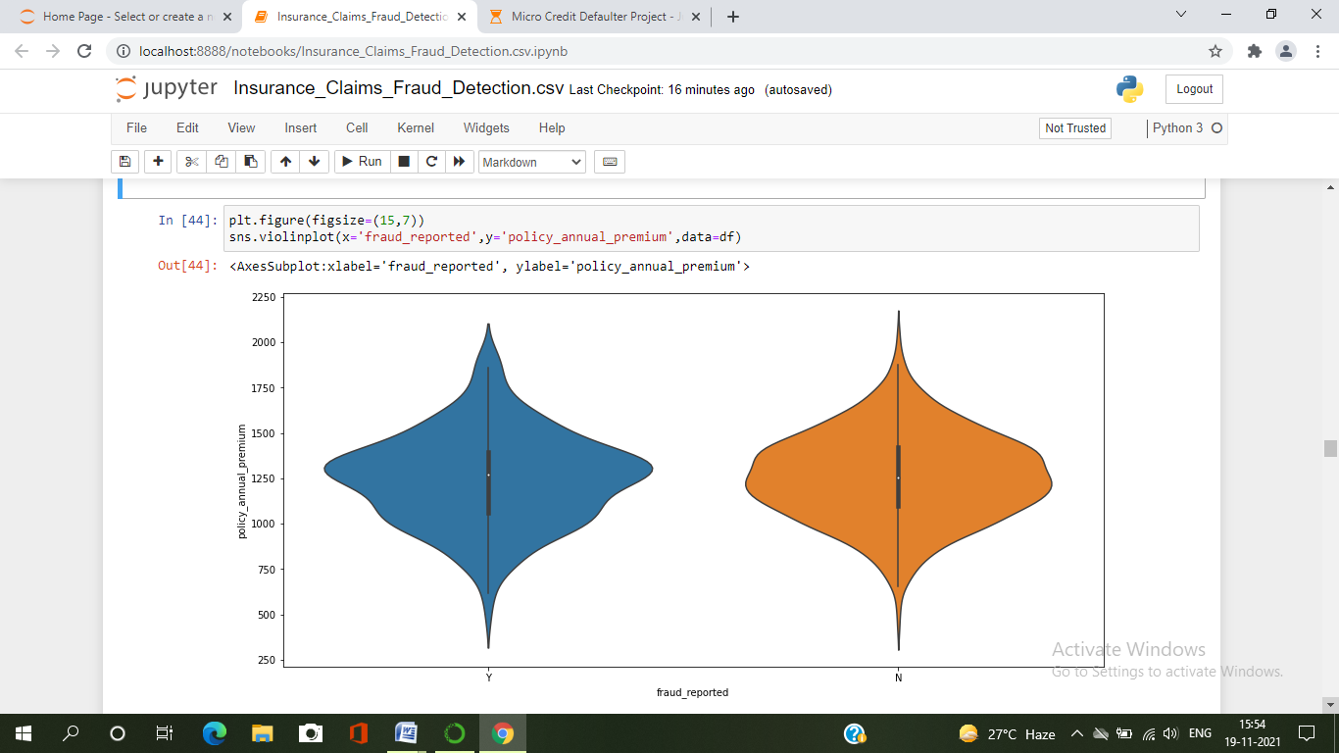

* Here I have used violinplot to compare fraud_reported and policy_annual_premium.
* We can observe from the above plot most of cx we have 1000 to 1500 of premiums payers.
* Most of the fraud reported we found in those premium is 1250 to 1300.

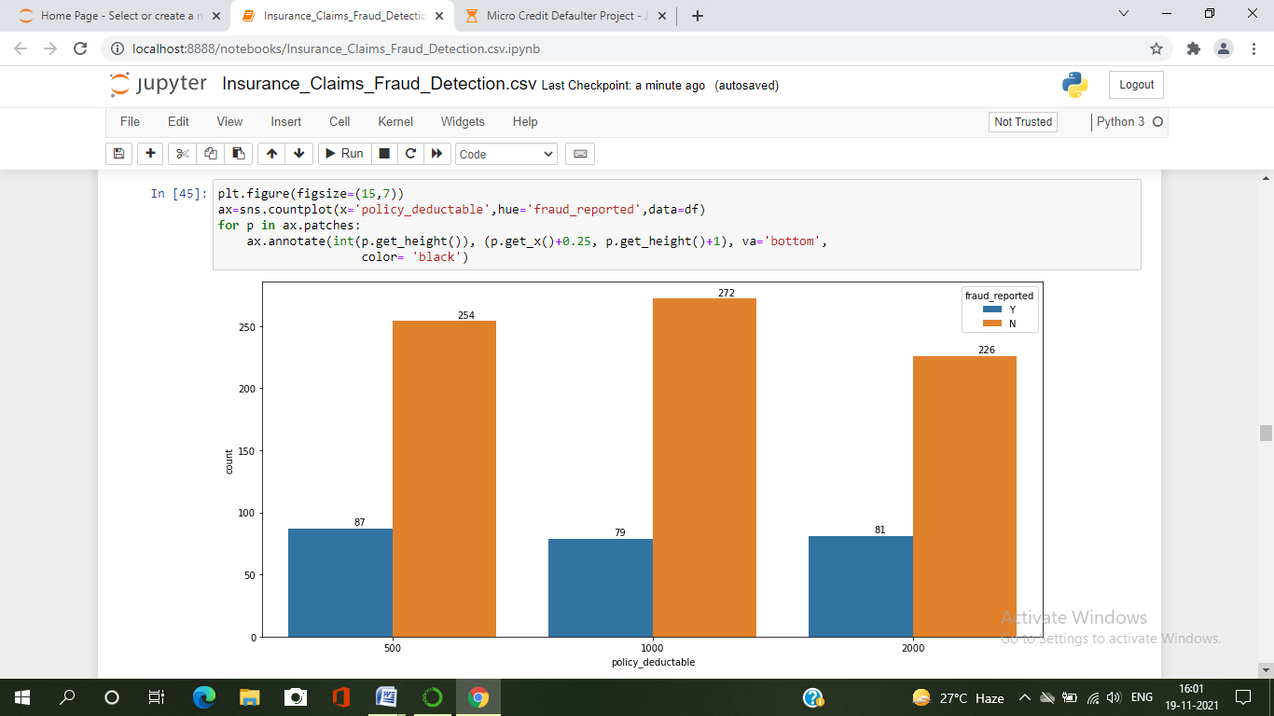

* Here I have used countplot to compare policy_deductable and fraud_reported . We can notice here according to count fraud report high in cx of 2000 policy_deductable

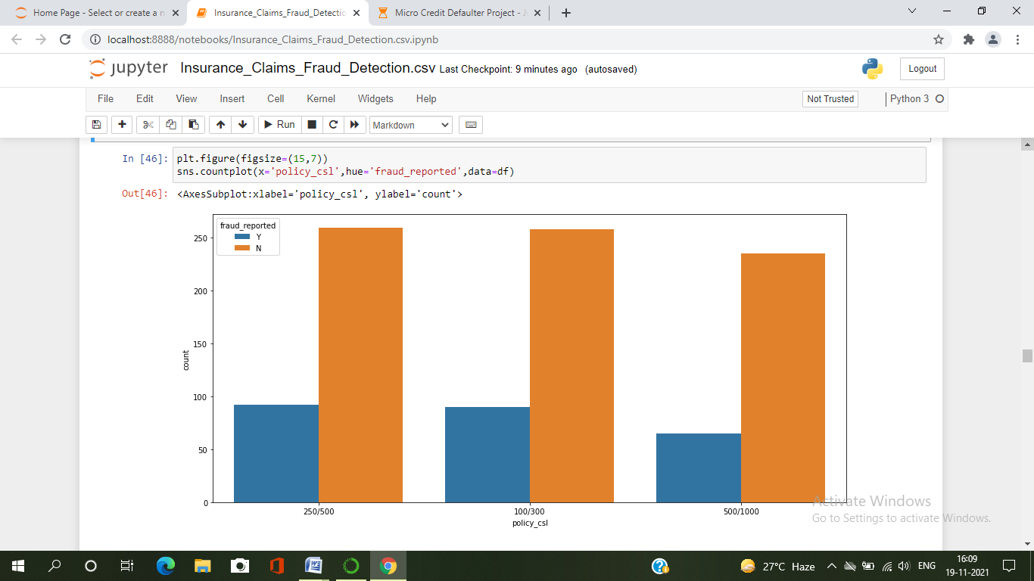

* Here I have used countplot to compare policy_csl and fraud_reported.
* From the above plot we can clearly see in all three csl we have same kind of similarity fraud report is also common in all policy_csl.

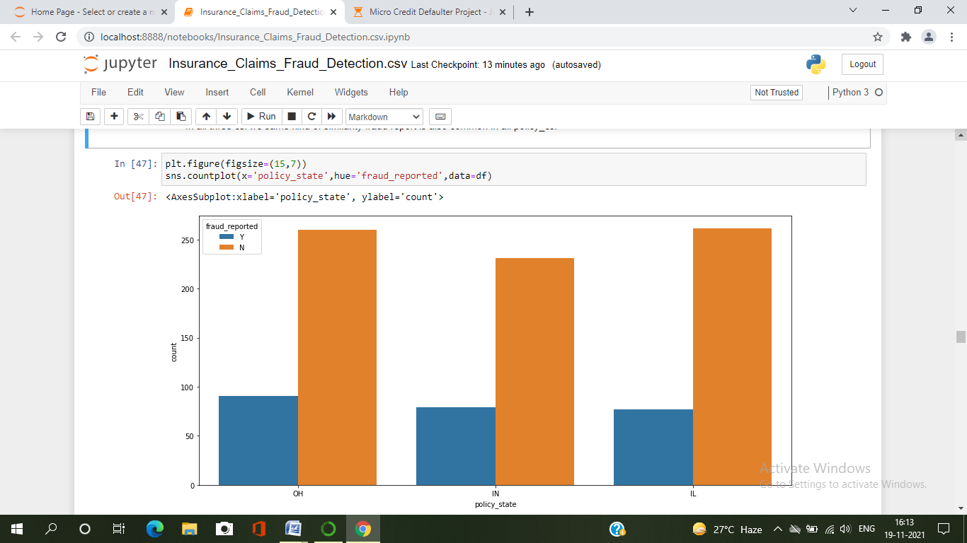

* Here I have used countplot to compare policy_state and fraud_reported.
* We have cx from three stats and fraud report almost common in all three states.

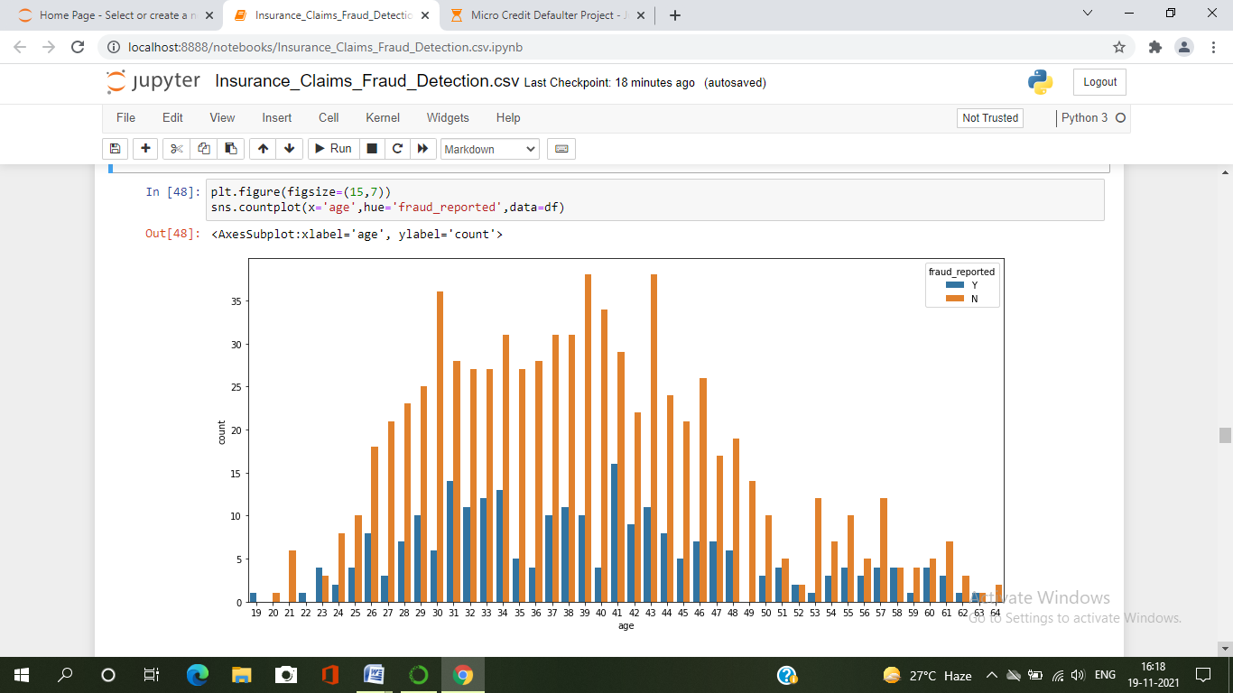

* Here I have used countplot to compare age and fraud_reported.
* We can see most of the cx are age of 26 to 50
* Fraud reported is higher in cx 26 to 50 of age.

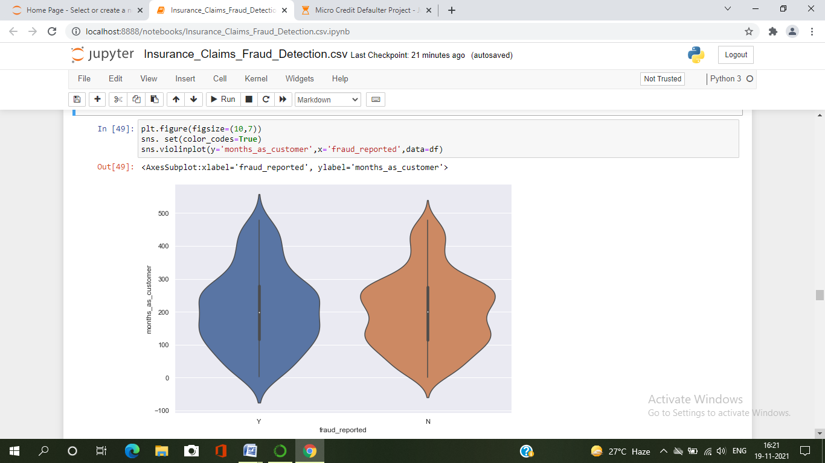

* Here I have used violonplot to compare months_as_customers and fraud_reported.
* From the above plot we can observe most of the cx are 100 to 300 months old
* We can notice here fraud report is high in cx between 100 to 250 months old.

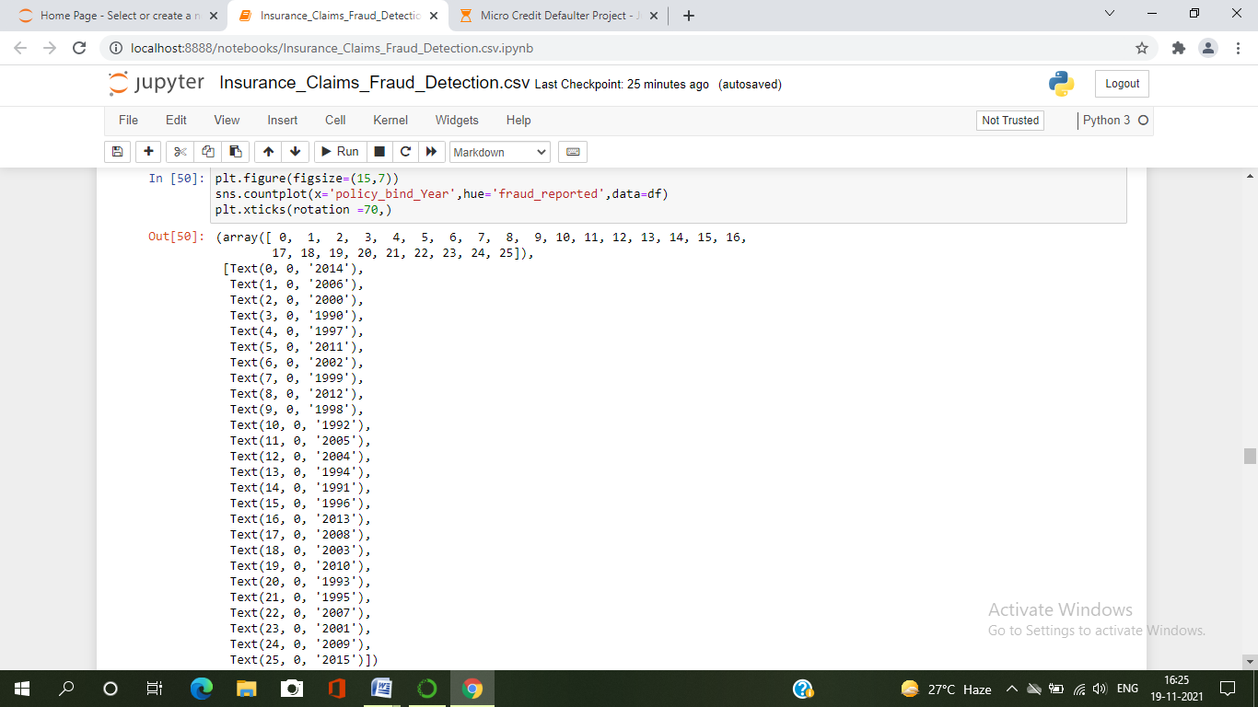

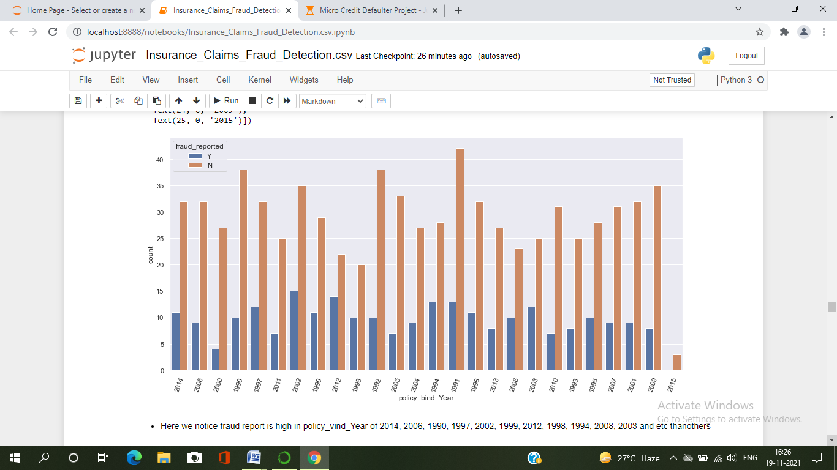

* Here I have used countplot to compare policy_bind_year and fraud_reported.
* We can notice fraud report is high in policy_bind_Year of 2014, 2006, 1990, 1997, 2002, 1999, 2012, 1998, 1994, 2008, 2003 and etc than others.

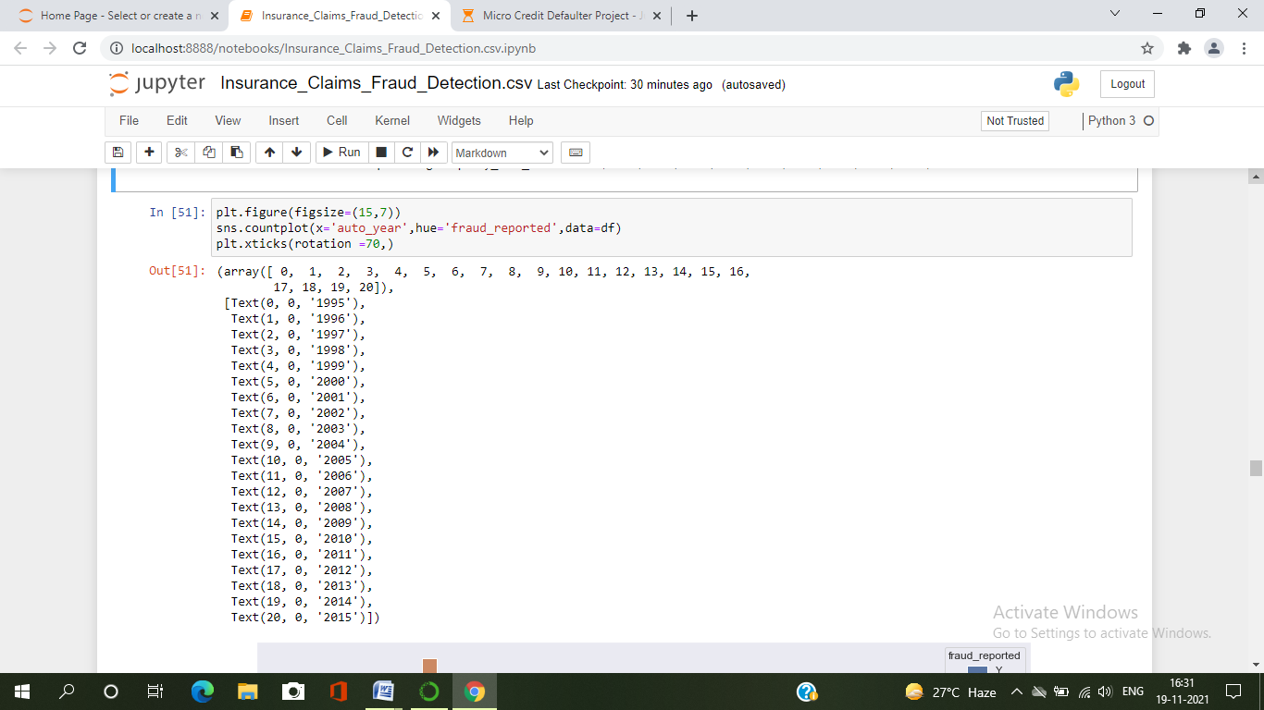

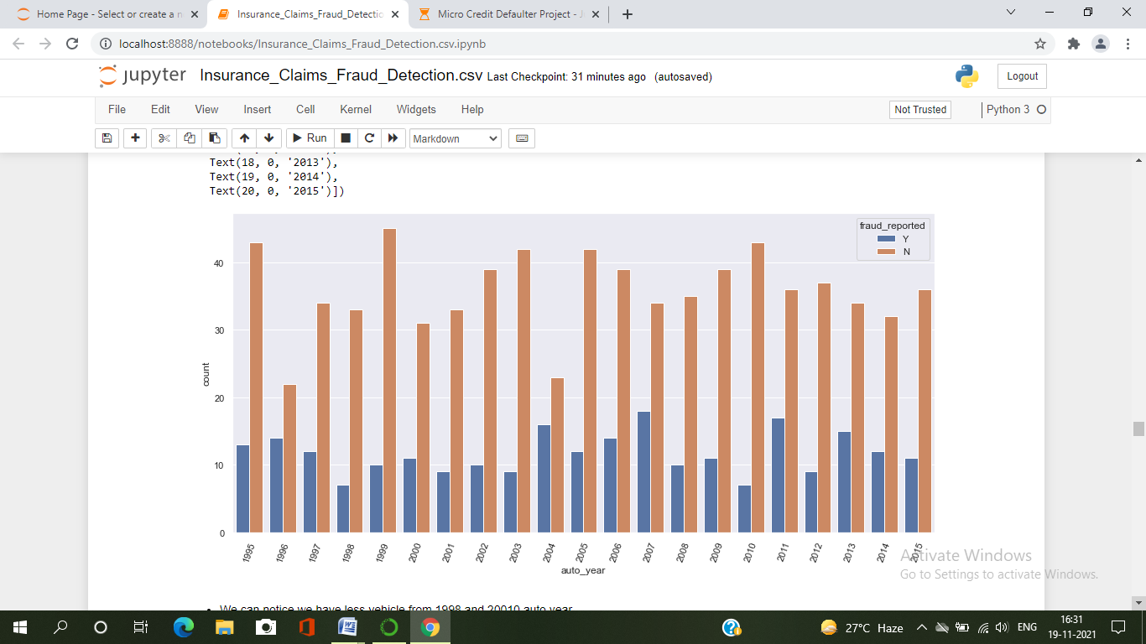

* Here I have used countplot to compare auto_year and fraud_reported.
* We can notice we have less vehicle from 1998 and 2010 auto year.
* According to vehicle count fraud reported is higher in vehicle of 1996, 2004, 2007, 2011, 2013, 2014 and etc auto year than others.

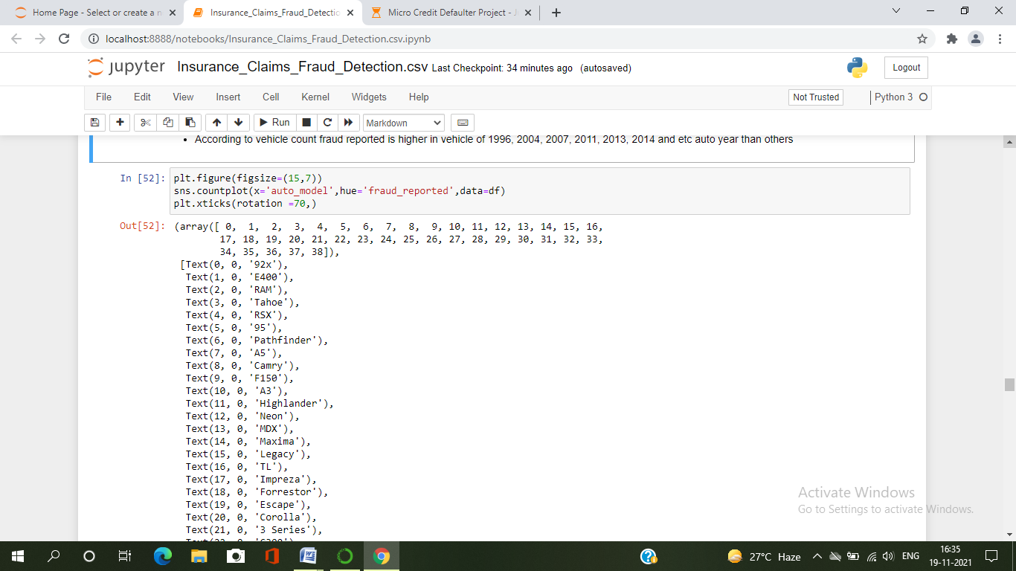 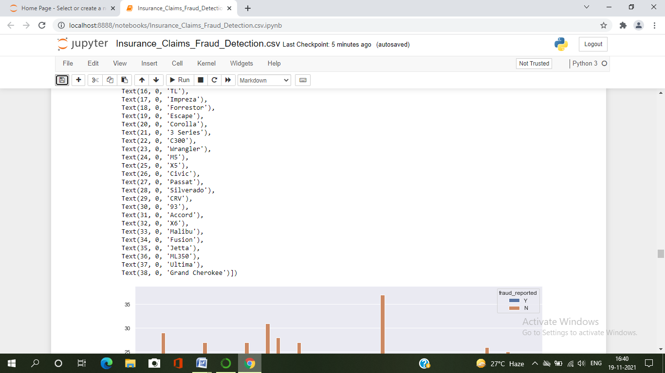

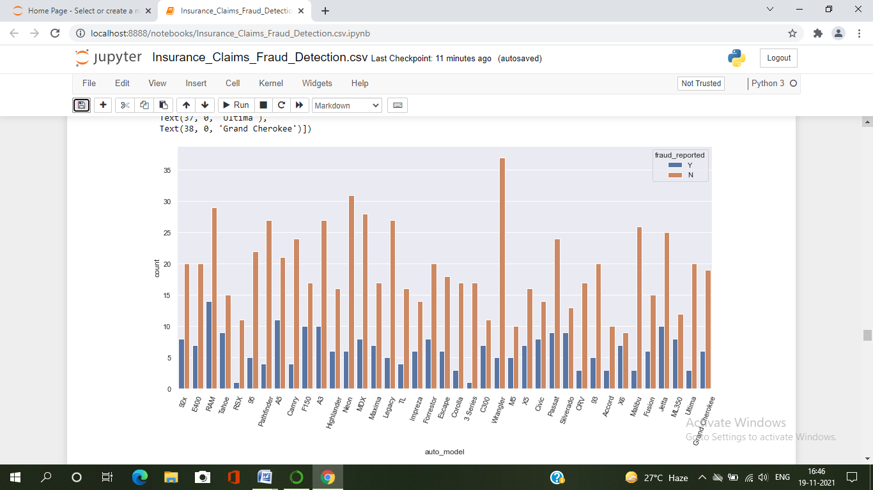

* Here I have used countplot to compare auto_model and fraud_reported.
* A we can notice most of auto_model we see in Wrangler, RAM , Pathfinder, Neon and etc.
* We can notice Fraud report is higher in 92x, RAM, E400, Tahore, A5, F150, X5, C300, M5, CIVIC, SILVERADOX6 ML300 and etc auto_models.

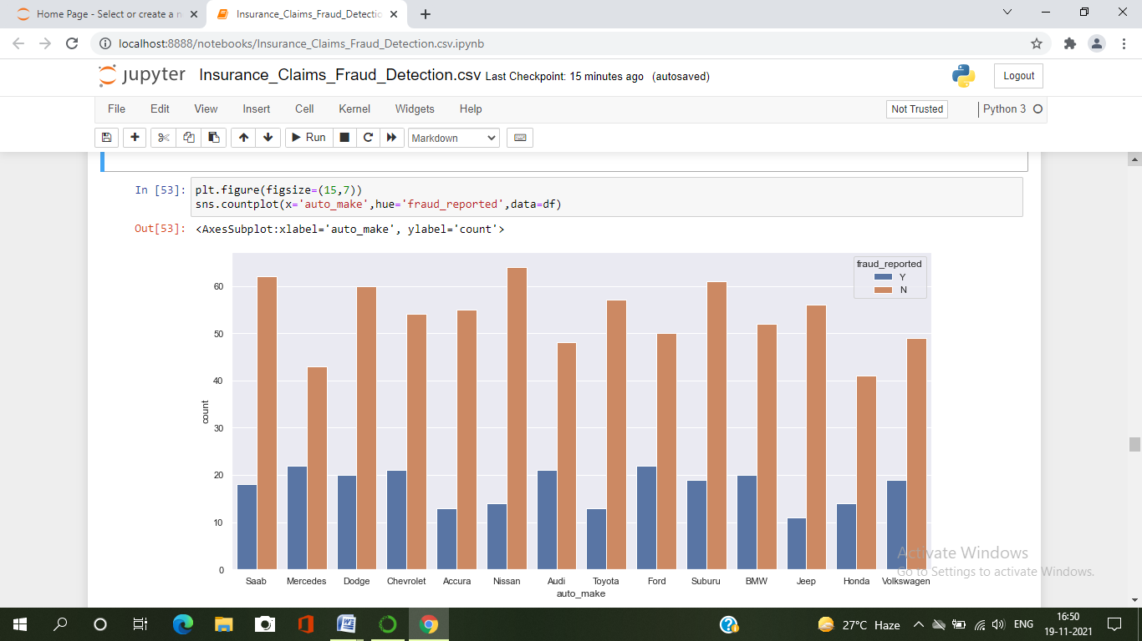

* Here I have used countplot to compare auto_make and fraud_reported.
* We can observe Fraud reported claim is higher in Saab, Merceded, Dodge, Chevrolet, Audi , Ford, Suburu BMW and volkswagen auto_make.
* In Other Auto_make brand is less than other.

Have done the analysis of all the important features, which makes a good visualization. Some of features don’t have much information to define.

1. ***EDA Concluding Remark.***

* I have checked the null values in the dataset and there was no missing values found.
* I have dropped some of the irrelevant columns to overcome with the multicollinearity problem.
* I have extracted some new features from the existing features to get better results without any hindrance. And dropped the old columns, if I keep them as it is they will act as duplicates and that leads to multicollinearity problem.
* Replaced the corrupted entries “?” in the columns with their respective mode values.
* Coming to the visualization part, we have found when and where the fraud reports are high in number.
* To get the better insights about the features, I have used violin plots, box plot , count plot and distribution plots.

***Checking Outliers and Skewness in the data***

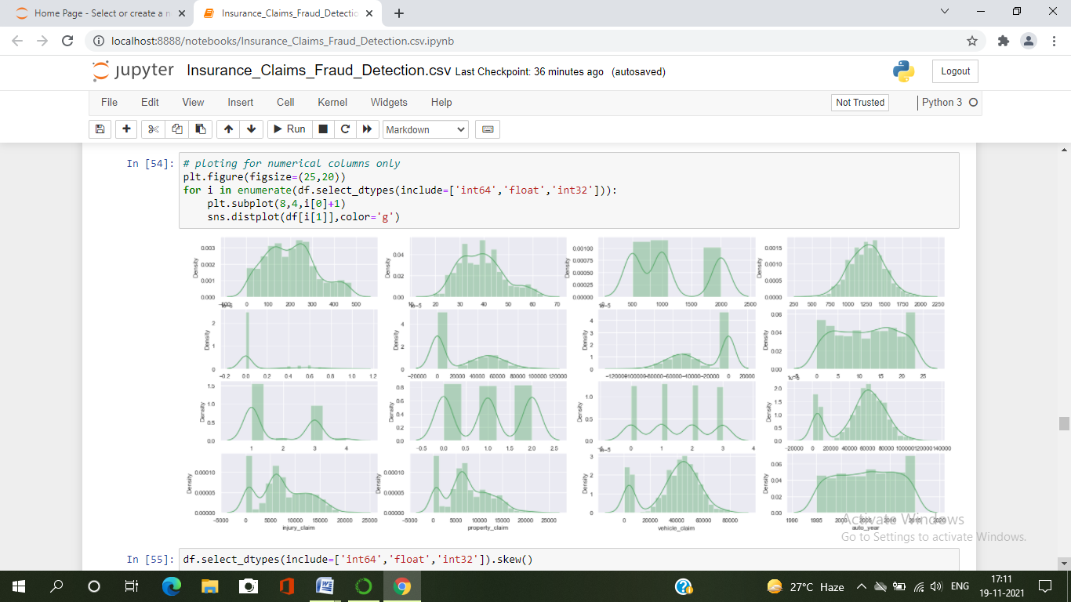

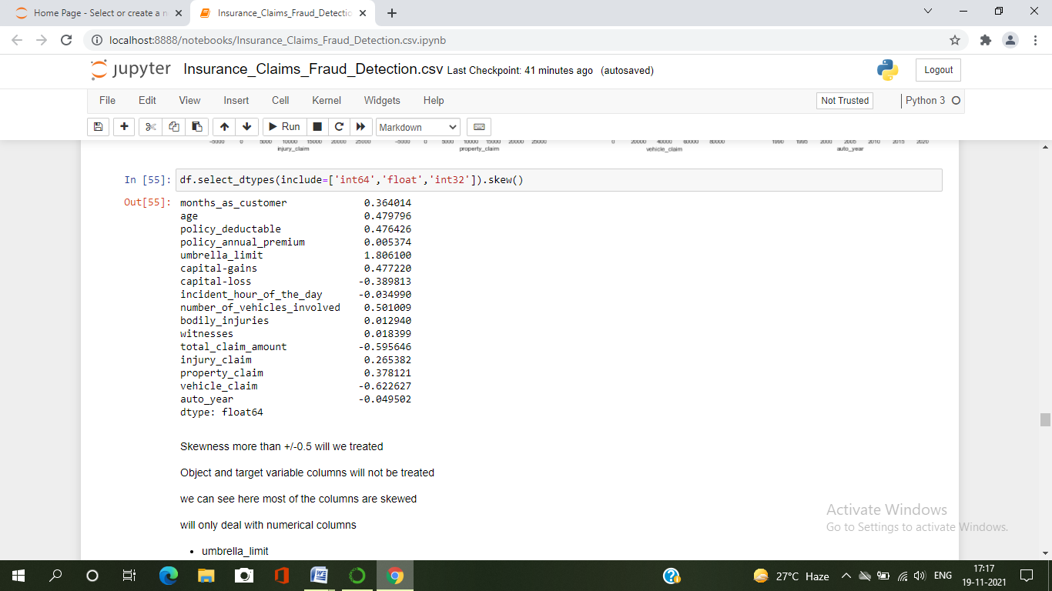

* Skewness more than +/-0.5 will we treated ,Object and target variable columns will not be treated.
* we can see here most of the columns are skewed so will only deal with numerical columns
* umbrella_limit
* total_claim_amount
* vehicle_claim

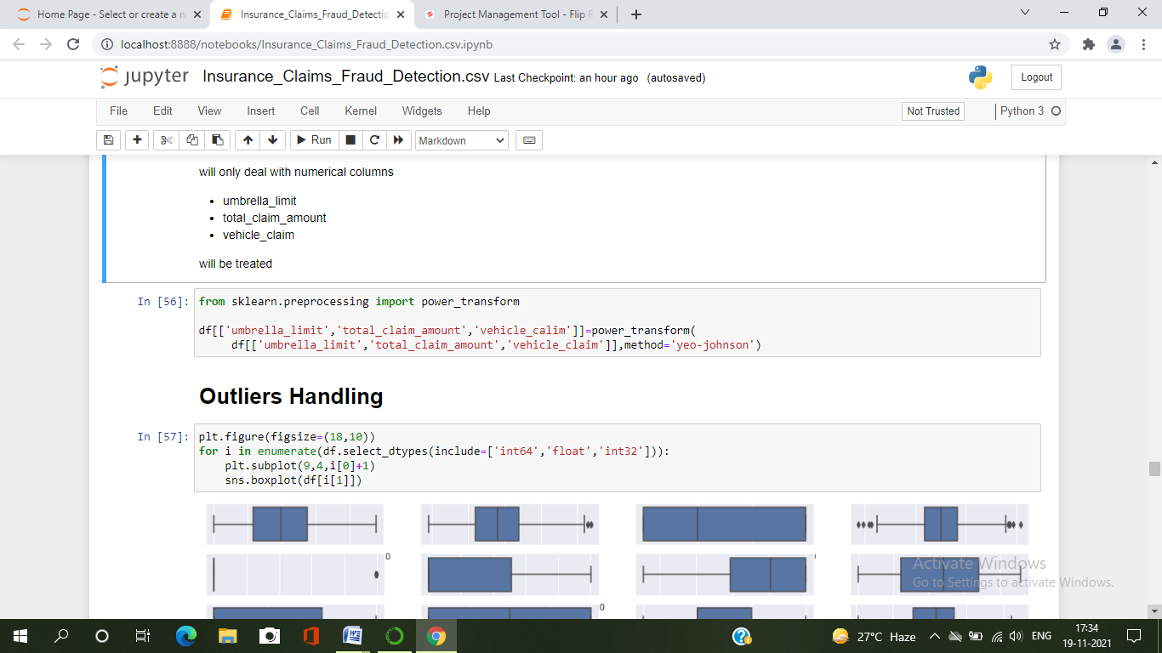

* I can notice the skewness in total_claim_amount, vehicle_claim and umbrella_limit, So here I used power transformation method(yeo-johnson method) to remove the skewness in the data. After using it, the skewness has been reduced.

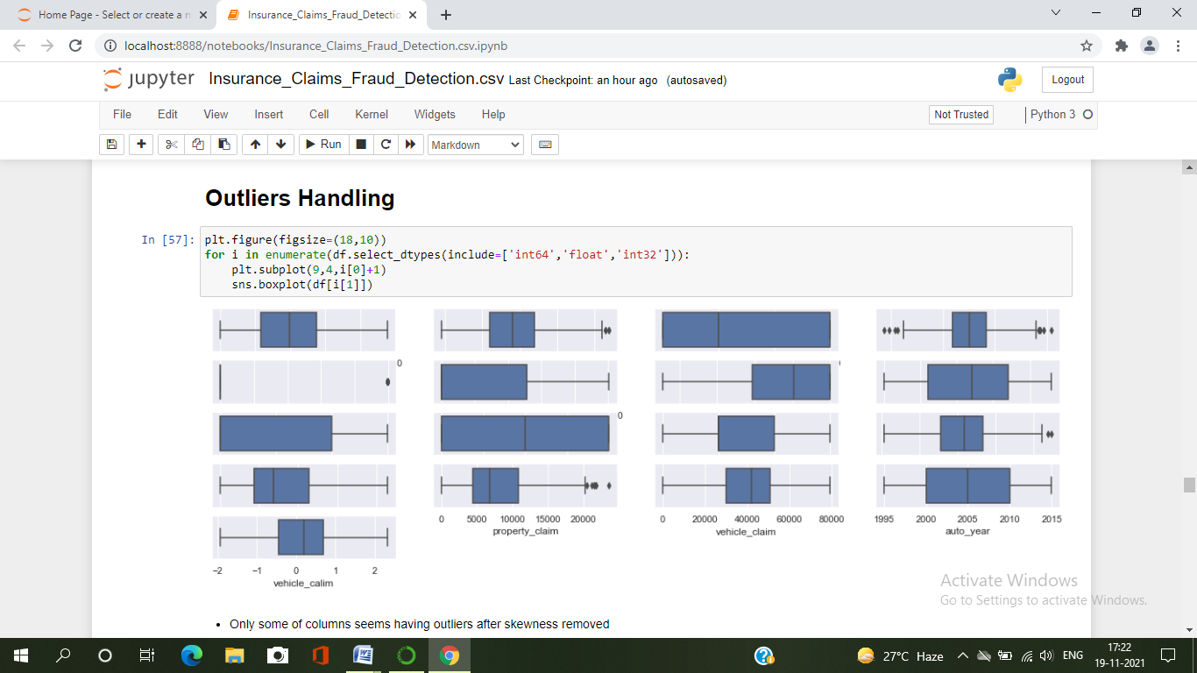

* Here I have used boxplot to check the outliers in the dataset and found outliers in age, policy_annual_premium, total_claim_amount, property_claim and incident_Month.

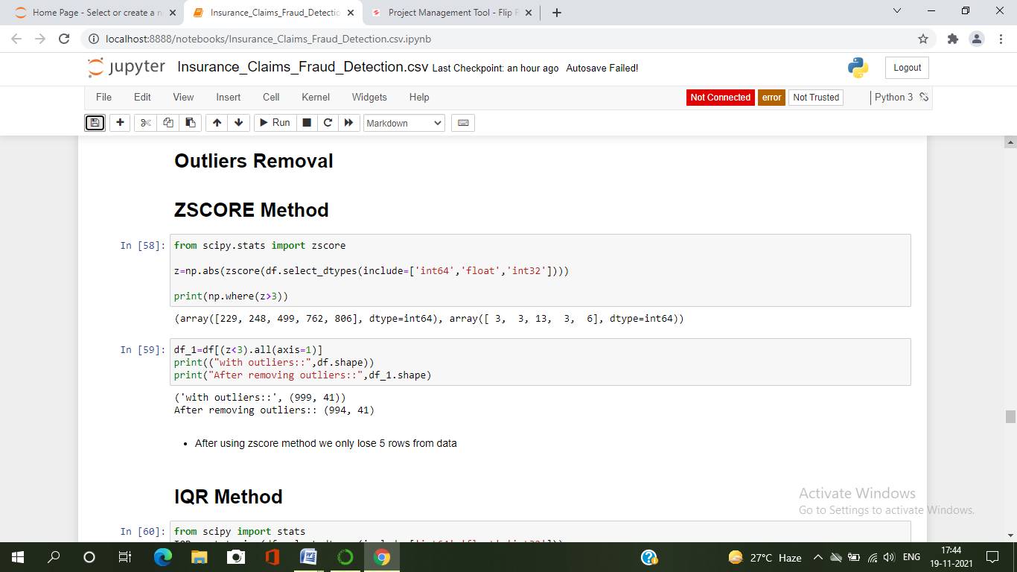

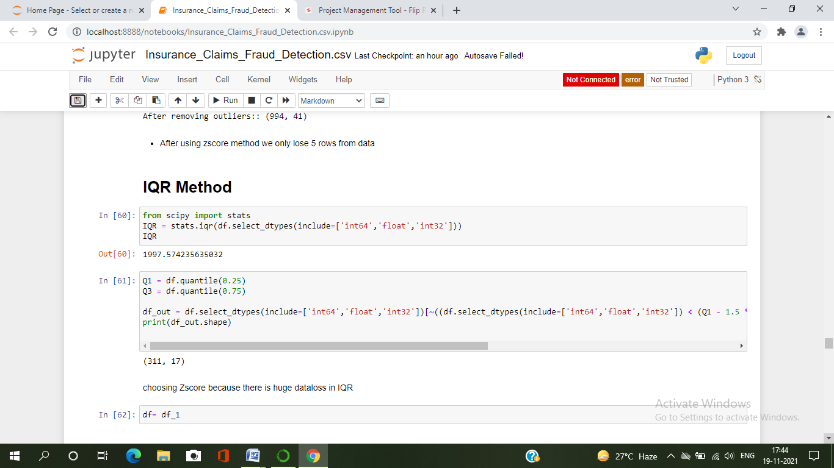

* To remove outliers, I used both Zscore and IQR method. Using Zscore, I got 0.5% data loss and in IQR method I got about 68% of data loss which is huge. So , I decided to consider Zscore and process my model.

We can notice our data is almost normal and skewness is also removed. Now we can proceed further.

Since our dataset contains object data. We need to encode them using any of the encoding methods. Here I have used label encoding method.

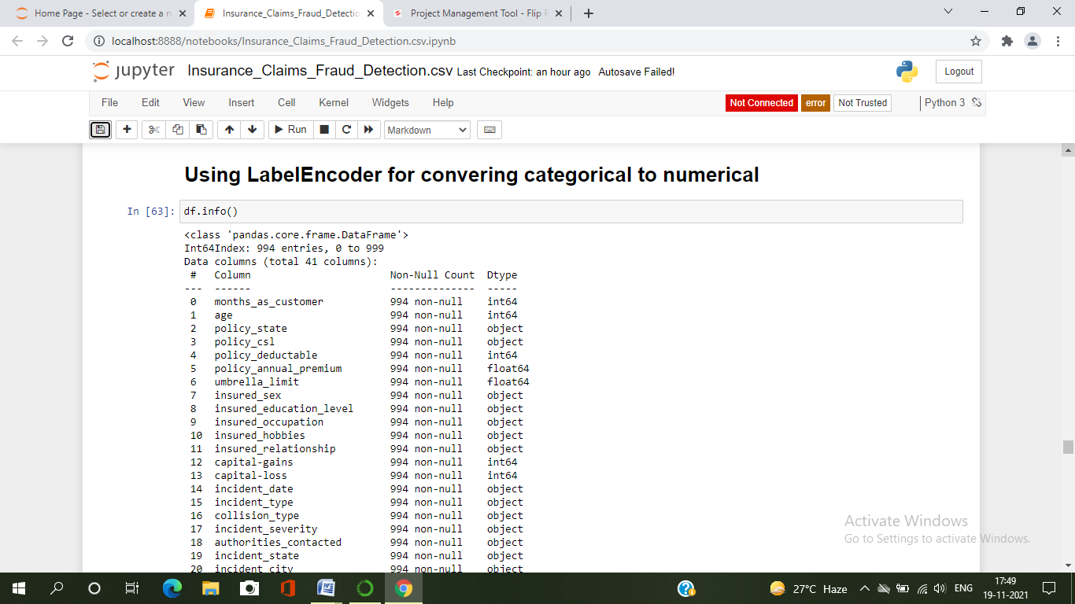 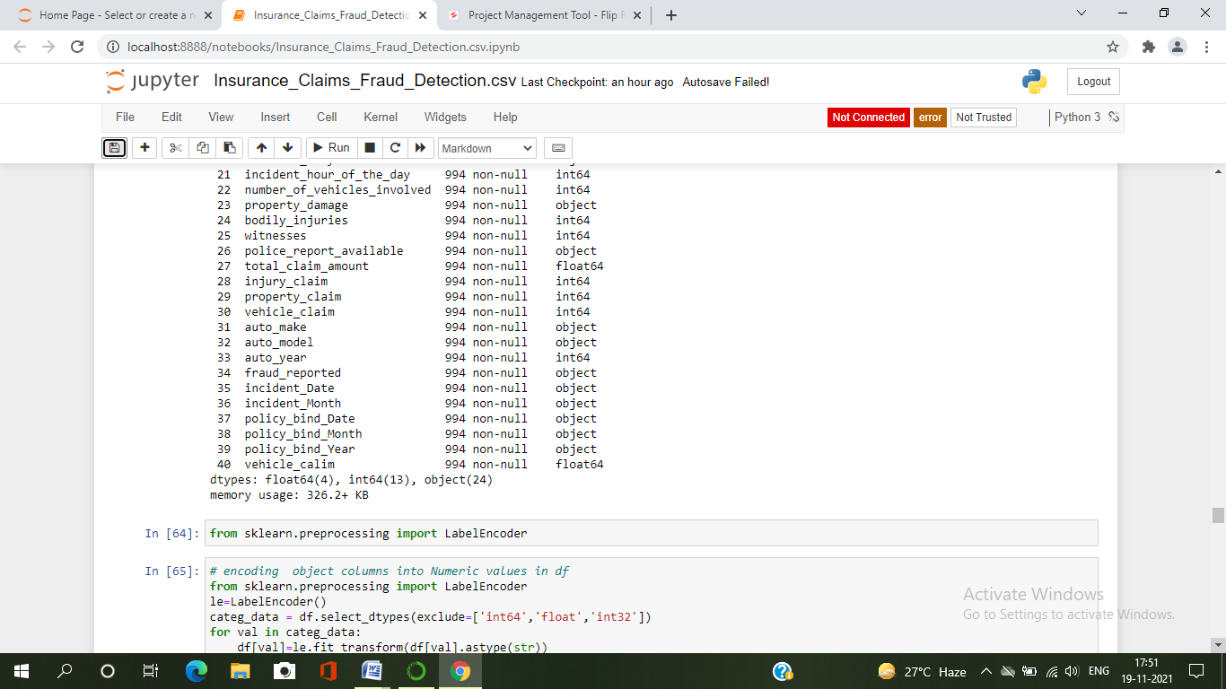

I have applied label encoding method to our cleaned dataframe new_df and converted the categorical columns into numerical.

1. ***Pre_Processing Pipeline***

First , I have to separate the label and features to process my dataset.

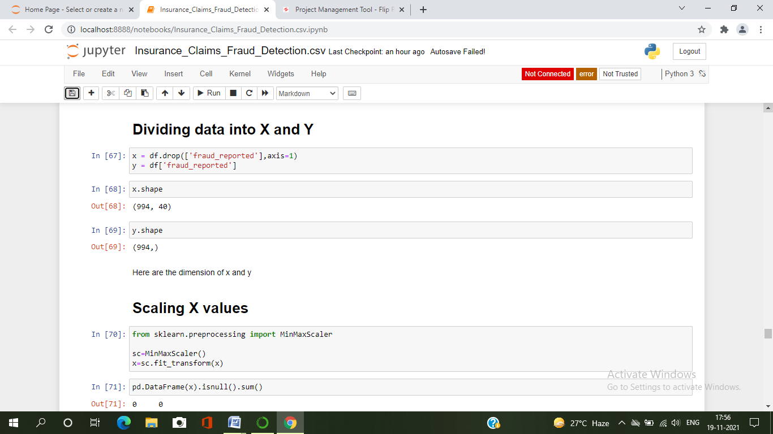

I have separated independent and dependent features and stored them in x and y respectively.

* Now, I have to scale the data containing independent variables (x) in order to overcome with the data biasness.
* Since I have removed the skewnes and outliers and my data is also normal so I can use Standard Scaler method to scale the data.if it is not the case then we could use MinMaxScaler.



* So here I have scaled the data using MinMaxScaler method to overcome with the issue of data biasness.
* Since I have come across the data imbalance issue, I need to fix it either oversampling or undersampling the data.
* And I always prefer to go with oversampling, because in under sampling there will be huge data loss.

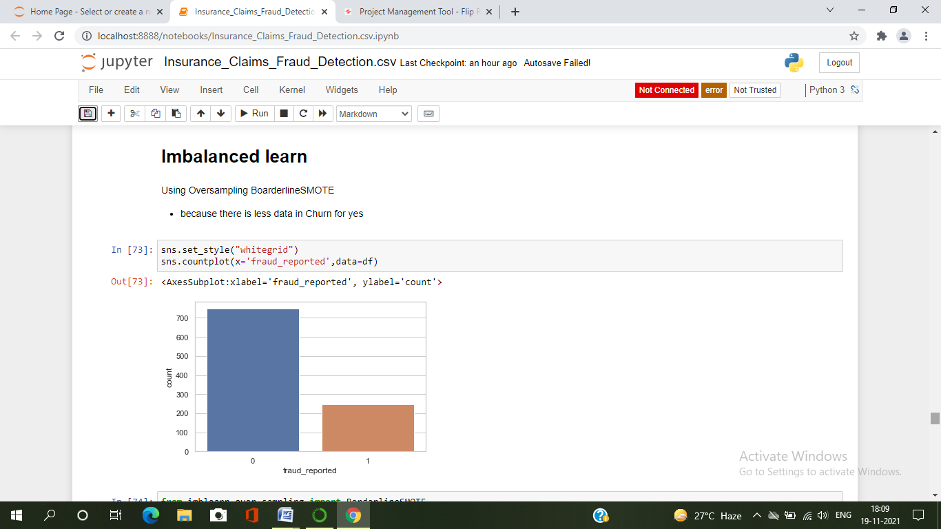 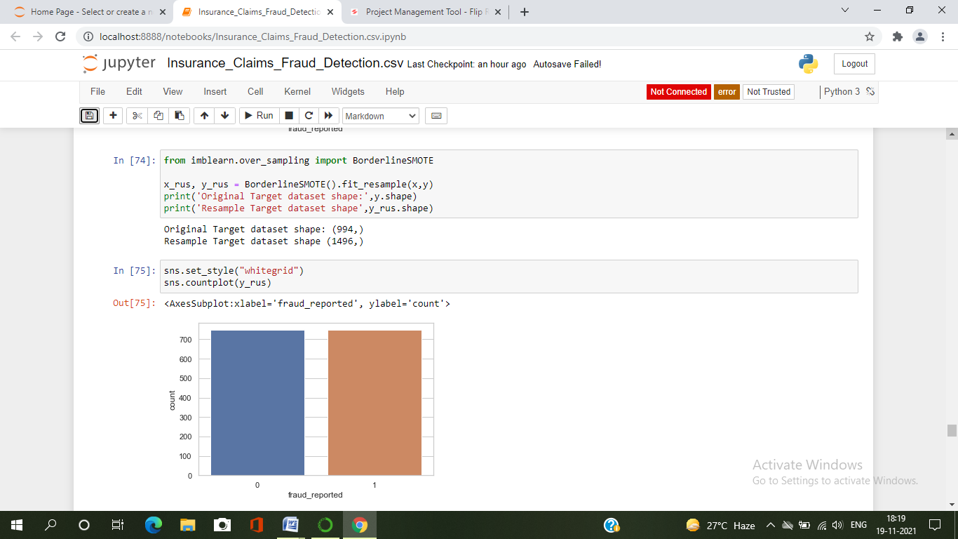

The data is now balanced that we can observe in the countplot.

Since I have done all the pre processing an data cleaning, now my data is ready to build the model. Let’s get the predictions by creating some classification algorithms as it is a classification problem.

1. ***Building Machine Learning Models***

Before building the models, first we need to create new train and test and fit them into the models to find our ideal model.

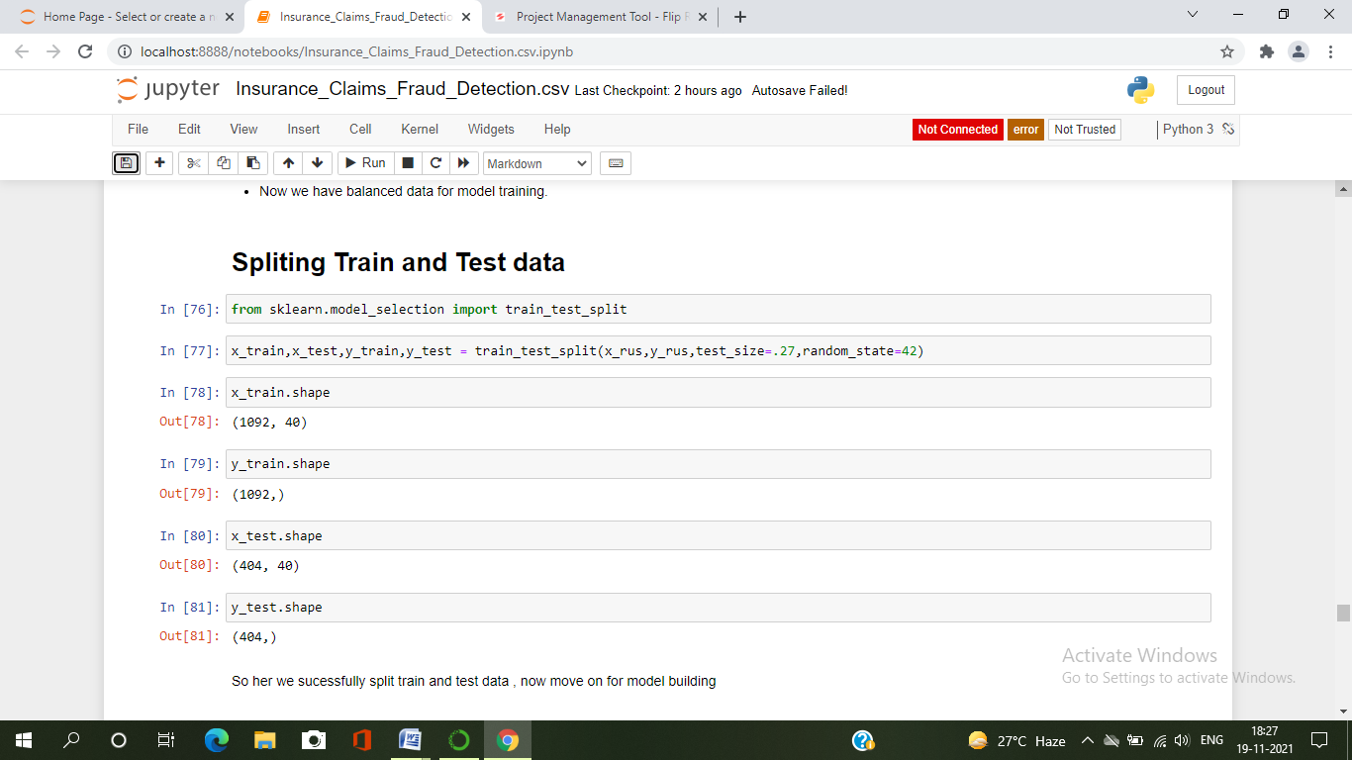

So here I have created new train and test data as x_train,x_test and Y_train,y_test.

Classification Algorithms

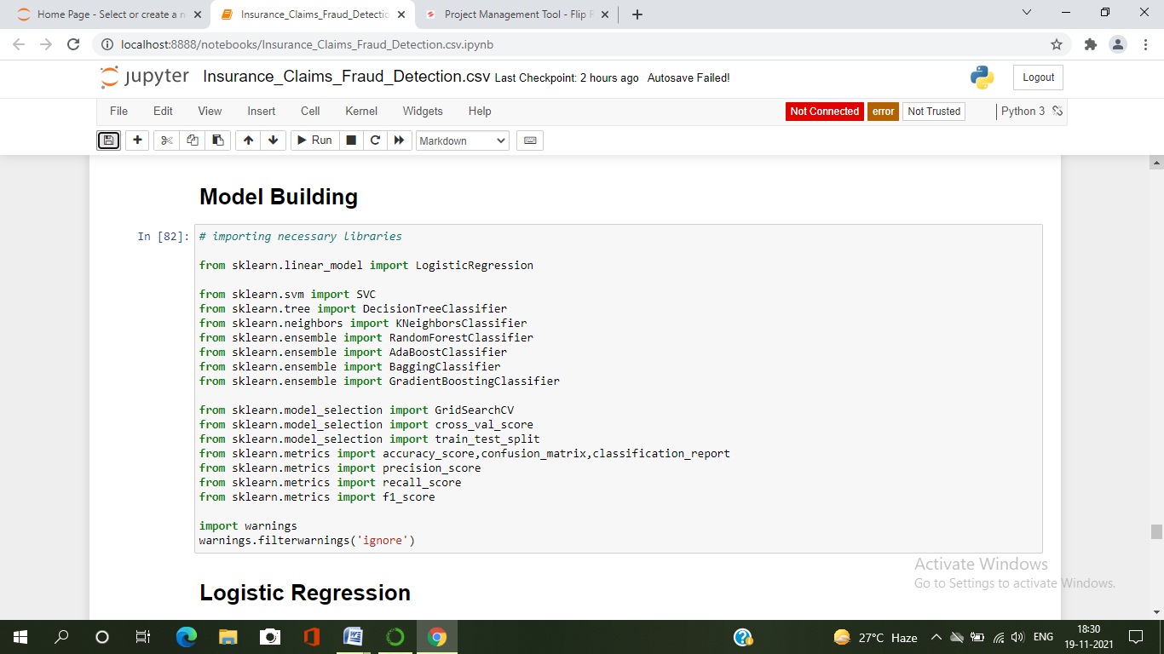

* I will be using the above classification algorithms to get the ideal one for prediction.
* I have used evaluation metrics like classification report, confusion matrix, roc score and and cross validation score to get the difference from the model accuracy.

**Logistic Regression**

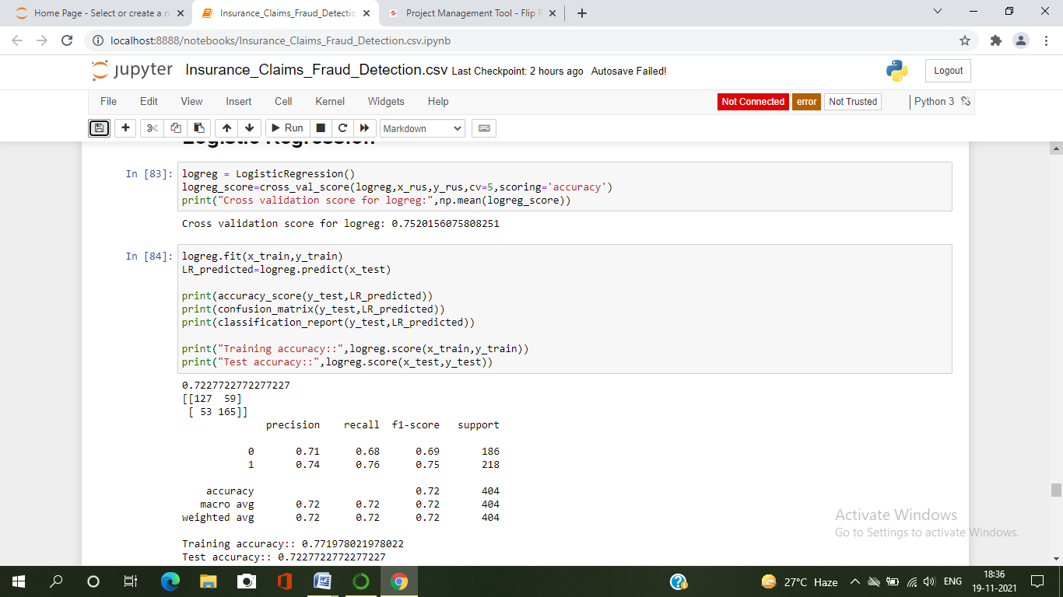

* Created a Logistic Regression Classifier and it is giving good accuracy score as 72.27 % and cross validation score is 75.20% . It gives best accuracy but let’s check other models.

**Decision Tree Classifier**

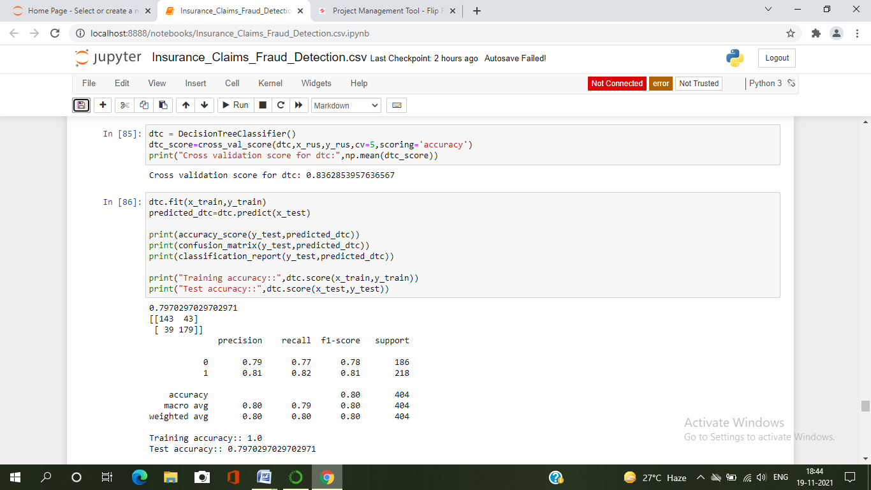

* Created a Decision Tree Classifier and it is giving good accuracy score as 79.70 % and cross validation score is 83.62% .

**KNeighbors Classification**

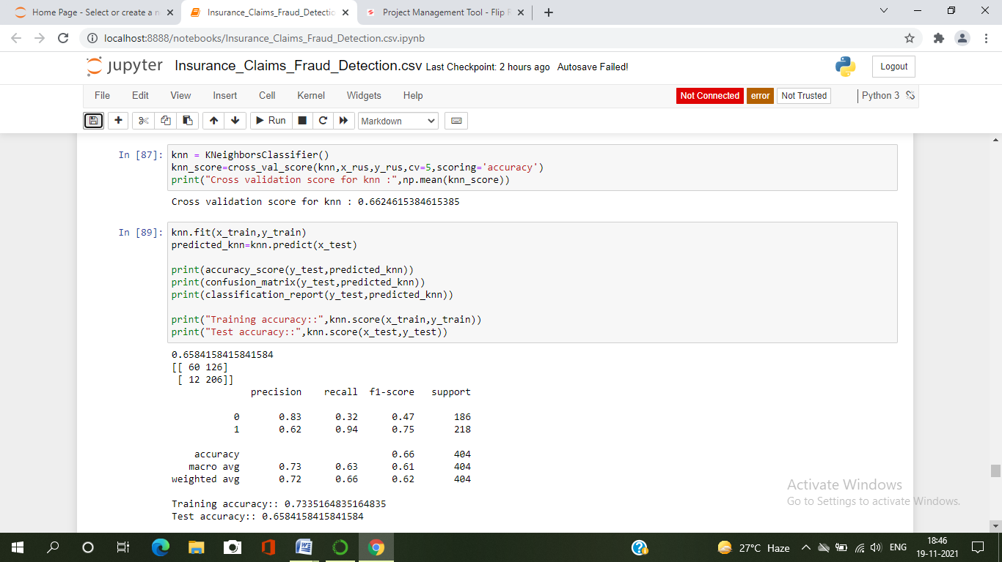

* Created a KNeighbors Classifier and it is giving good accuracy score as 65.84 % and cross validation score is 66.24% .

**Random Forest Classifier**

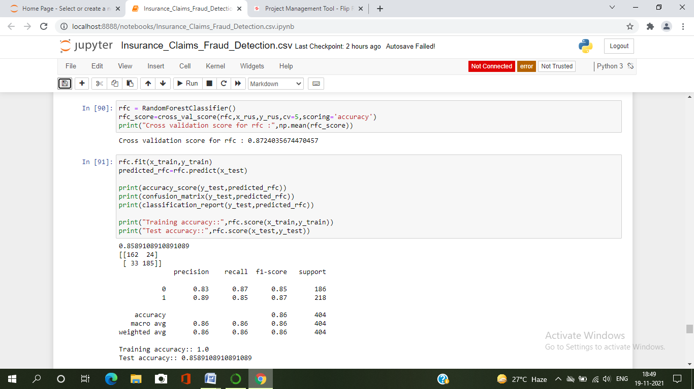

* Created a Random Forest Classifier and it is giving good accuracy score as 85.89 % and cross validation score is 87.24% .

**Ensembel Techniques**

**Ada Boost Classifier**

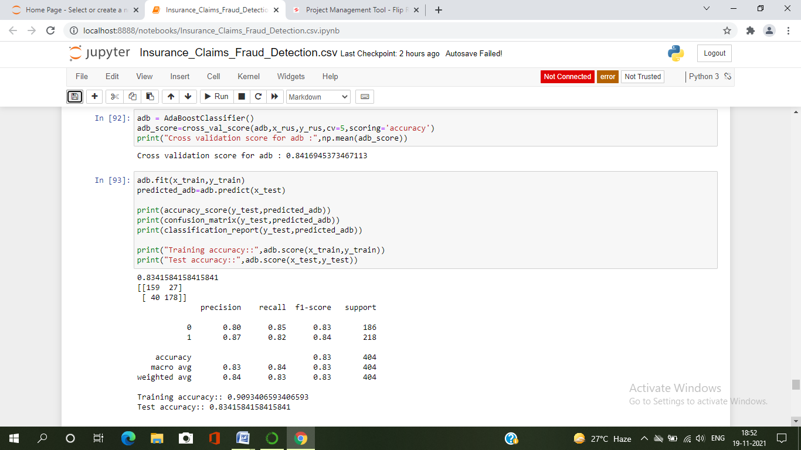

* Created a AdaBoost Classifier and it is giving good accuracy score as 83.41 % and cross validation score is 84.42%

**Bagging Classifier**

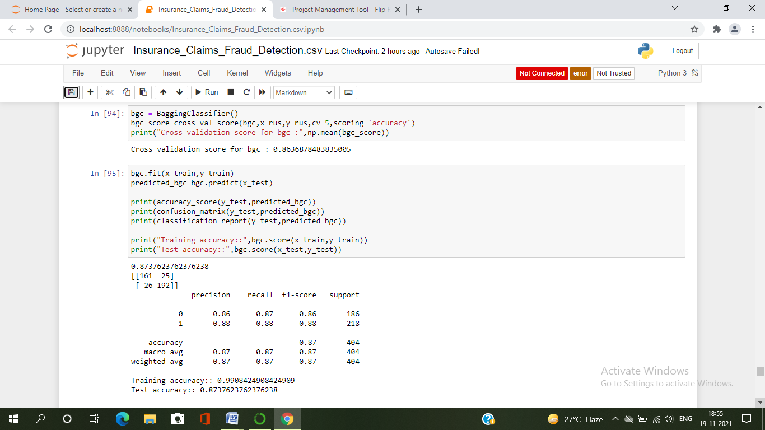

* Created a Bagging Classifier and it is giving good accuracy score as 87.37 % and cross validation score is 86.36%

**Gradient Boosting Classifier**

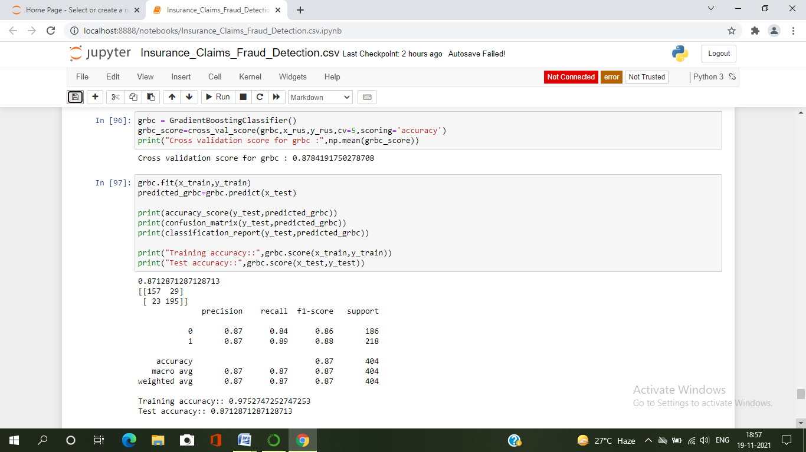

* Created a Gradient Boosting Classifier and it is giving good accuracy score as 87.12 % and cross validation score is 86.84%.

From the difference between the accuracy score and cross validation score, we can conclude that **Gradient Boosting Classifier** as our best fitting model for prediction which is giving very less difference of 0.28%.

Based on these results I am performing hyper parameter tuning to improve my accuracy.

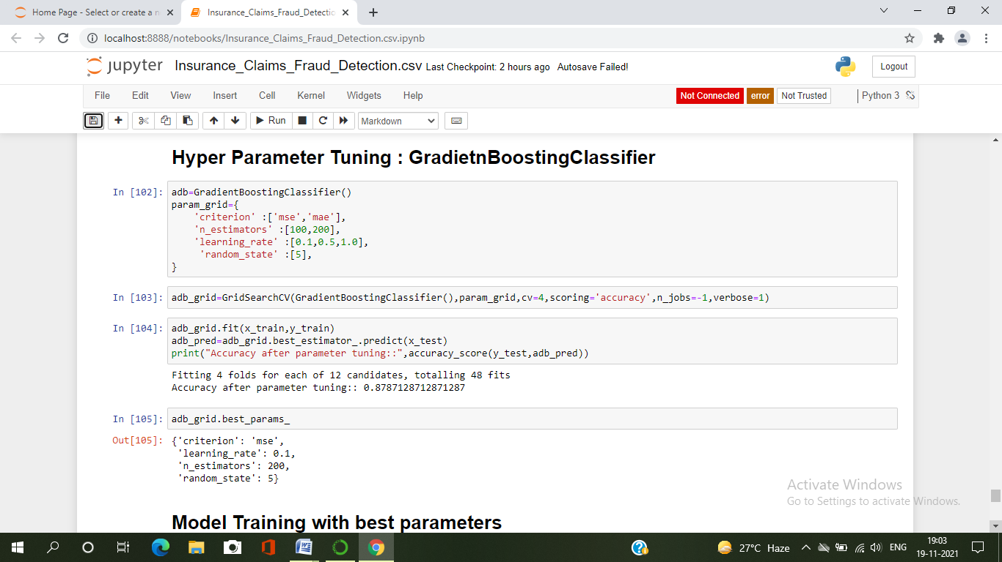

By using above parameters, I am tuning my best model and after tuning I have to choose the best parameters from the above list.

Let’s get the best parameters.

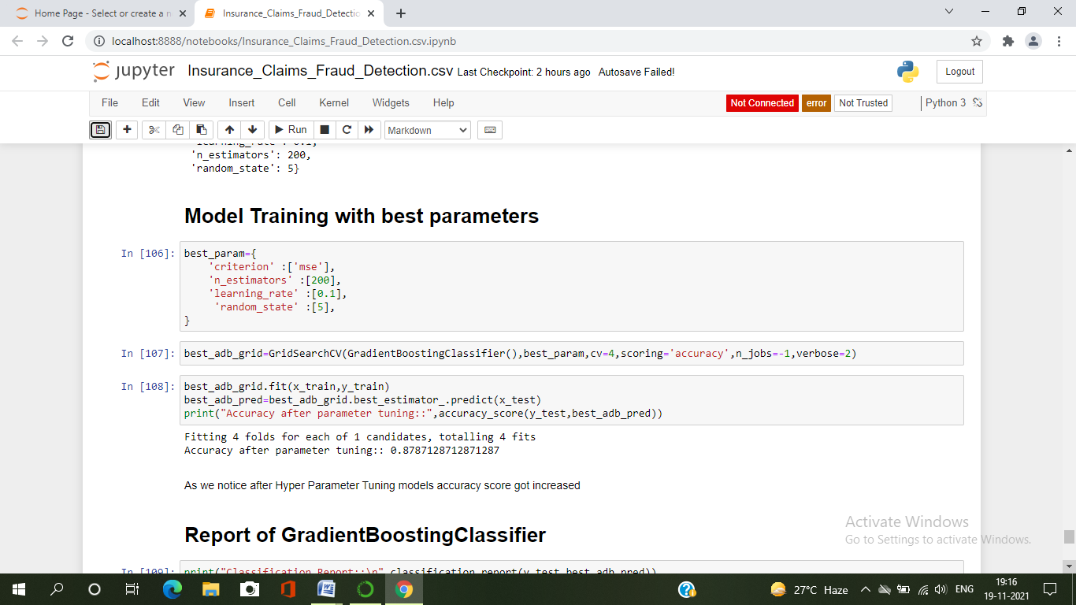

I ran GridSearchCV and find the best parameters. And also use these parameters to get the accuracy of the best model.

So after tuning my model, the accuracy got increased and now the accuracy is 87.87%.

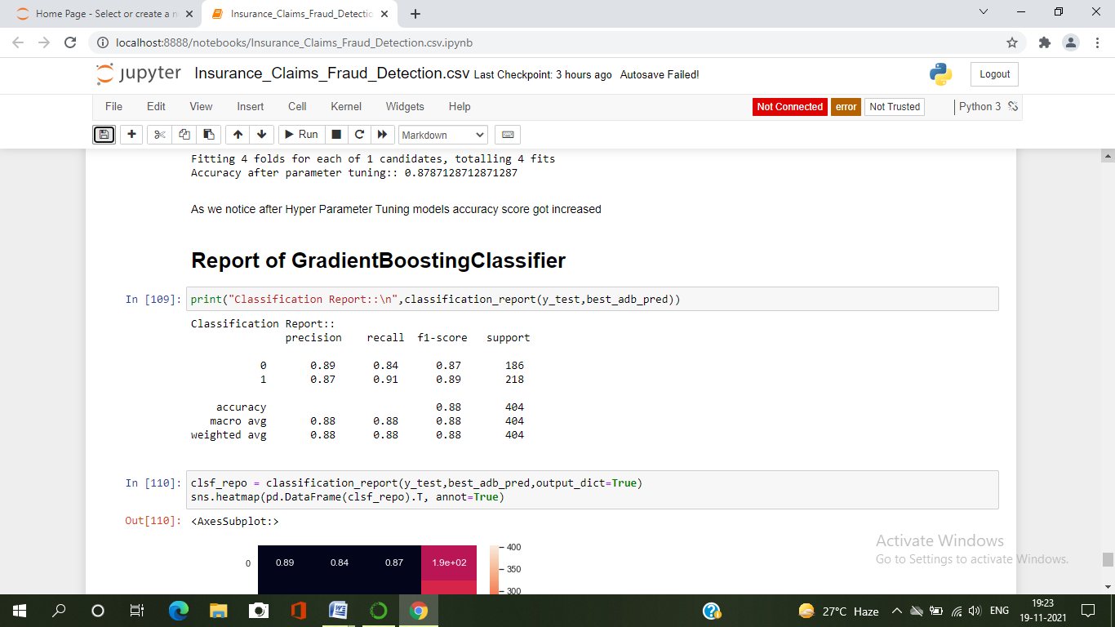 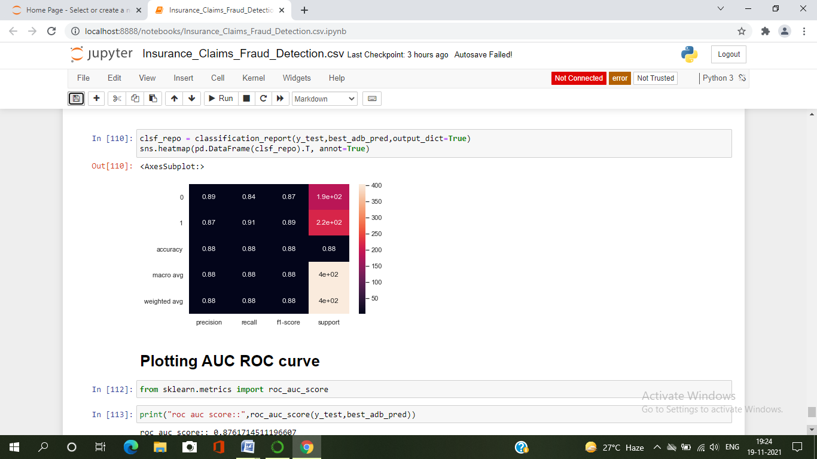

Now we will plot ROC curve and compare the AUC for the best model.

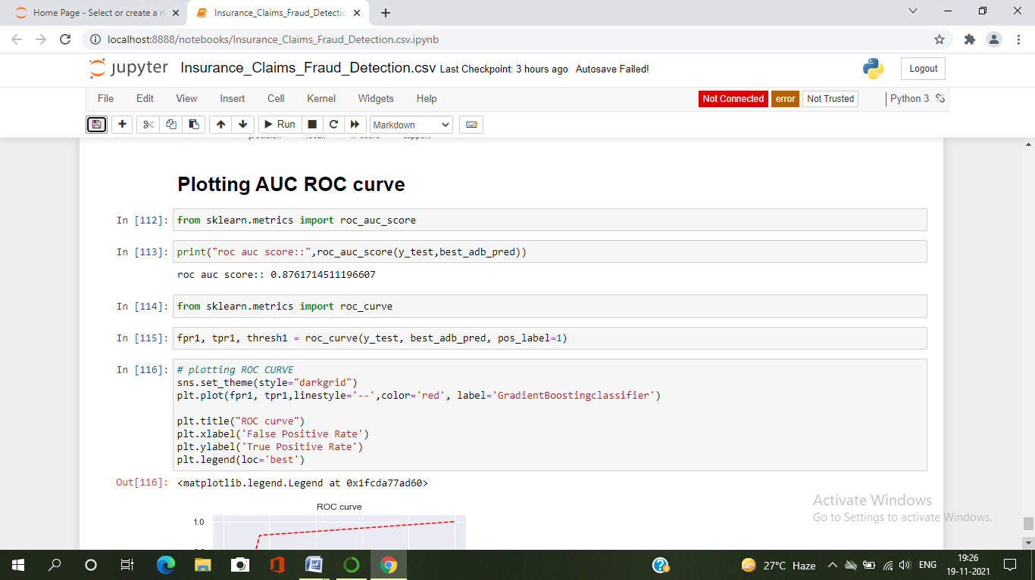 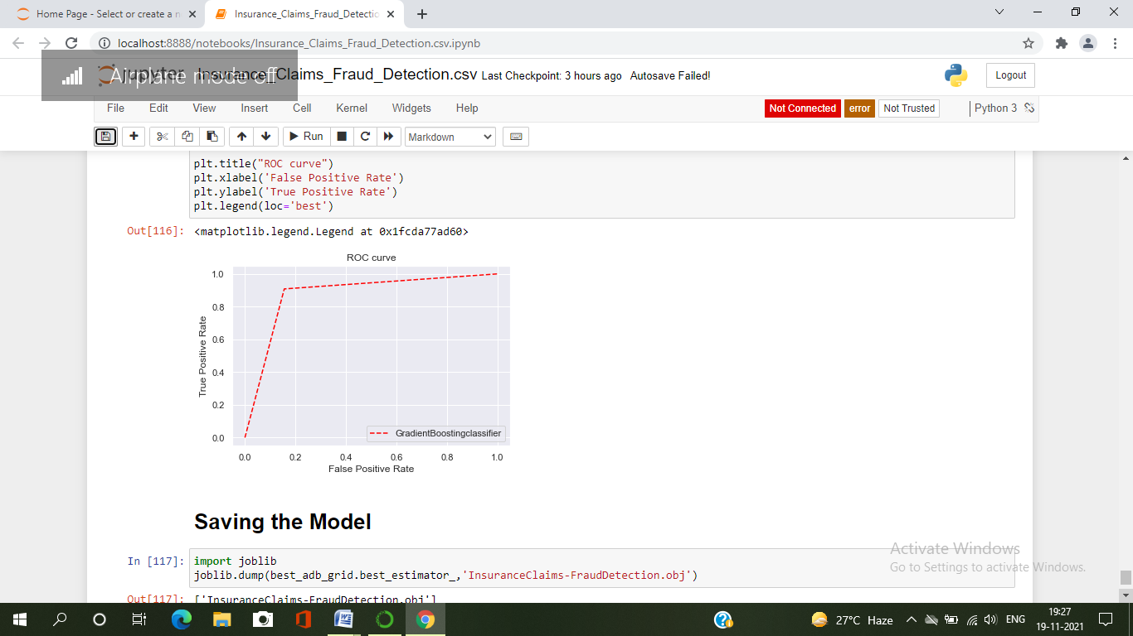

The AUC value is also remained same as before. Since I have done with the model building. It’s time to save the model.

Here I have saved the models by using joblib library, .obj as below

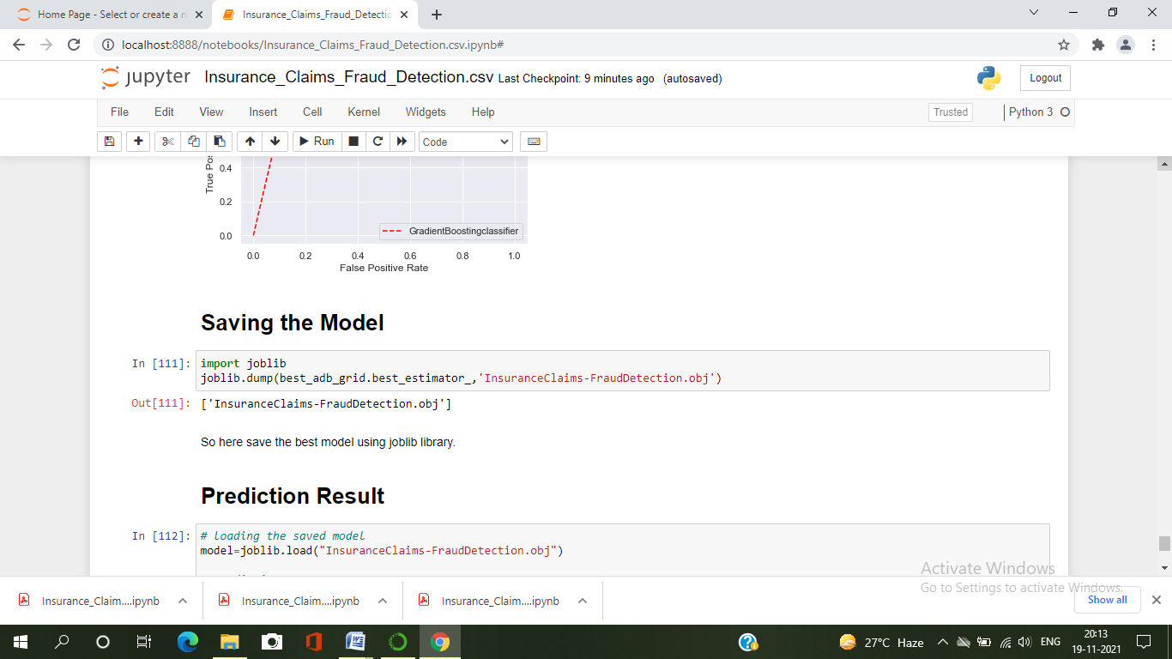

**Prediction Results**

By loading the saved model, now I can predict whether the insurance claim is fraudulent or not.

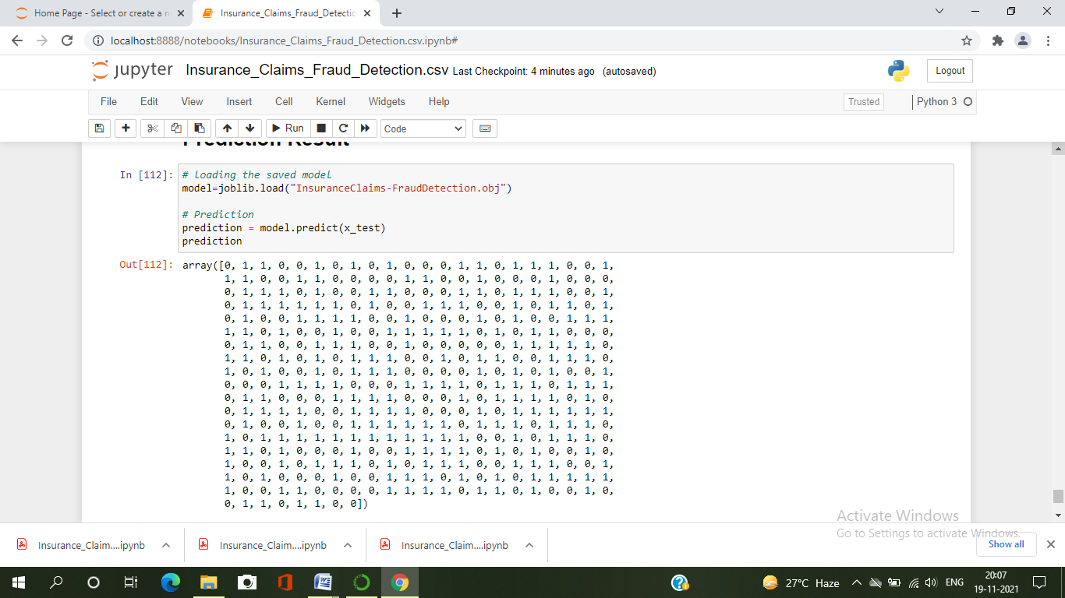 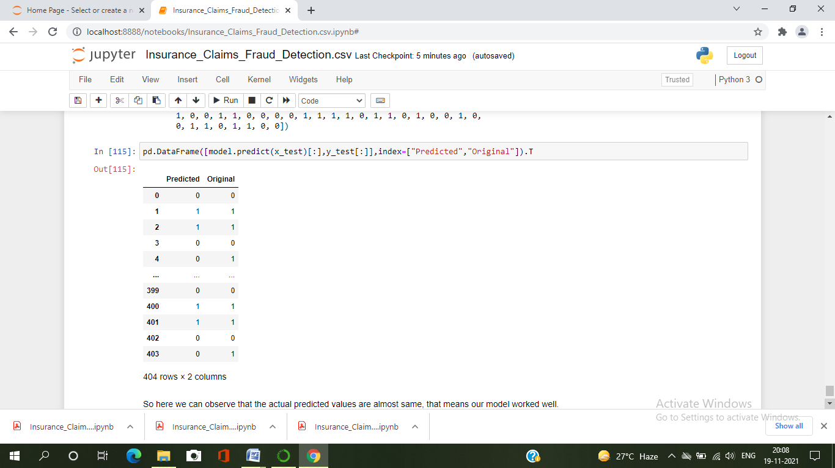

From the above result we can observe that the actual and predicted values are almost same, that means our model worked well.

1. ***Concluding Remark***

In this project we have gone through the feature engineering which is the most crucial thing and removed the outliers and skewness. Also handled the categorical columns by encoding the data, scaled the data and at last, we built different classification models to predict whether the insurance claim is fraudulent or not and performed the hyper parameter tuning to improve the model by using different parameters.

With the help of above techniques, our model is able to predict the fraudulent report with the accuracy of 87.87% . Also , we have seen the actual and predicted values are almost same that means our model worked correctly.

Building machine learning models for such problems can help the insurance companies to choose the correct insurer. So, Machine learning techniques are very useful to solve these kind of problem.

***********************************************